

Talent Pilot Application Documentation
  - Leadership technical brief | Current implementation source of truth | June 5, 2026
AI advises; humans decide. Talent Pilot uses algorithms, workflows, LLMs, and vector search to support hiring, but final control stays with authorized users.

Prepared from current repository code, SQL scripts, architecture notes, and live application screens. No Stitch/reference screenshots are included. Secret values are excluded.

Document Summary
Section summary
- Talent Pilot is a multi-tenant hiring and resource fulfillment application.
- The app uses Angular 21, .NET 8, SQL Server, Dapper, SignalR, a worker service, Ollama, and SQL Server vector search.
- Authentication uses JWT access tokens and rotating refresh tokens stored by the frontend in localStorage or sessionStorage.
- Authorization is permission-based, with roles granting permissions and groups used mainly for workflow routing.
- Core flows cover job request intake, PMO review, bench matching, sourcing, publishing, applications, interviews, offers, and closure.
- AI agents assist with job descriptions, CV parsing, bench matching, talent rediscovery, online headhunting, applicant ranking, requirement indexing, fit explanations, decision briefs, conversational RAG, and interview-question generation.
- The current AI design prepares evidence with code and vector search, then requires LLM output for user-facing AI recommendations and summaries.
- The system uses embeddings and SQL vector search for ranking, conversational RAG answers, and question-bank retrieval.
- Admin Center owns tenant configuration, access control, hiring pipeline templates, workflow routing, notifications, AI settings, integrations, sources, and audit logs.
- Google Calendar creates interview events and Meet links today; conflict-aware slot suggestions are a roadmap enhancement.
- Candidate portal data can support market and hiring analytics when privacy, tenant isolation, and consent rules are respected.

This document is written in simple English and separates implemented behavior from roadmap recommendations.

Common Acronyms And Terms
Readers can use this table when a section mentions a short technical term or business abbreviation.
Term | Full meaning | Plain-English meaning in this application
AI | Artificial Intelligence | Computer systems that assist with tasks such as matching, ranking, drafting, and summarizing.
API | Application Programming Interface | A backend endpoint or contract that the frontend calls to read or change application data.
BCrypt | Blowfish-based password hashing function | A backend password-hashing algorithm/library. It stores password hashes, not plain passwords.
BFF | Backend For Frontend | A backend layer designed for one frontend. In auth, it can keep tokens server-side and give the browser only a secure cookie.
CV | Curriculum Vitae | The candidate resume/profile document uploaded during hiring.
DOCX | Microsoft Word Open XML document | The Word document format used for CV uploads and this documentation file.
FreeBusy | Calendar availability lookup | A calendar API pattern that returns busy time windows without exposing private event titles or descriptions.
HOD | Head of Department | A department leader role used for hiring ownership or approval context.
HTTP | Hypertext Transfer Protocol | The protocol browsers use to call web pages and APIs.
HttpOnly | Cookie security flag | A browser cookie setting that prevents JavaScript from reading the cookie.
JWT | JSON Web Token | A signed access token that carries user, tenant, role, and permission claims for API authentication.
LLM | Large Language Model | The AI model used for text generation or explanations, such as llama3.2 in the current runtime.
MVP | Minimum Viable Product | A focused product version that proves the main workflow before broader production hardening.
OAuth | Open Authorization | A standard used to let users authorize calendar or provider access without sharing their password with the app.
OCR | Optical Character Recognition | Technology that reads text from images or scanned documents. Talent Pilot does not currently perform OCR.
OIDC | OpenID Connect | An identity layer on top of OAuth 2.0, commonly used for enterprise single sign-on.
ORM | Object-Relational Mapper | A library style that maps code objects to database tables. Talent Pilot uses Dapper instead of a heavyweight ORM.
PDF | Portable Document Format | A common document format. Current MVP extraction expects DOCX; PDF/OCR parsing is roadmap work.
PII | Personally Identifiable Information | Personal data that can identify a person, such as email, phone, or candidate profile details.
PMO | Project Management Office | The operations team that reviews demand, routes work, and coordinates fulfillment.
QA | Quality Assurance | Checks used to confirm the document, software, or process behaves as expected.
RAG | Retrieval-Augmented Generation | An AI pattern where relevant stored knowledge is retrieved and passed to an LLM before it answers.
SLA | Service Level Agreement | A target for how quickly work should be completed, such as time spent in a workflow stage.
SQL | Structured Query Language | The language used to read and write data in SQL Server.
SSO | Single Sign-On | A login approach where users authenticate through an enterprise identity provider.
UI | User Interface | The screens and controls users interact with in the web app.
XSS | Cross-Site Scripting | A browser attack where injected JavaScript can try to read or change frontend data.

Executive Overview
Section summary
- Talent Pilot helps an organization move from hiring demand to fulfillment with one shared workflow.
- Main actors are Tenant Admins, Presales, PMO, Recruiters, Hiring Managers, HODs, Interviewers, Employees, and Candidates.
- AI supports drafting, parsing, matching, ranking, rediscovery, and decision explanation.
- Human users keep control over approvals, workflow movement, interview outcomes, offers, and hiring decisions.
- Tenant isolation lets the same product serve multiple organizations safely.
- Current implementation is the source of truth; older planning notes and Stitch screens are not used as evidence.

Talent Pilot is a hiring and resource fulfillment platform. It connects customer demand, internal bench visibility, recruiter sourcing, candidate applications, interviews, and final hiring decisions. The product is designed for organizations that need structured hiring operations, clear ownership, and AI assistance without giving AI final authority.
The strongest design idea is the combination of workflow control and AI assistance. Workflows keep the process auditable and predictable. AI agents reduce manual effort by drafting job descriptions, extracting CV facts, finding related talent, and explaining match evidence. The system records what happened so leaders can later measure bottlenecks, source quality, AI usefulness, and time-to-fill.
Current code wins over older notes. This documentation follows the running app, SQL scripts, source code, and canonical architecture files.

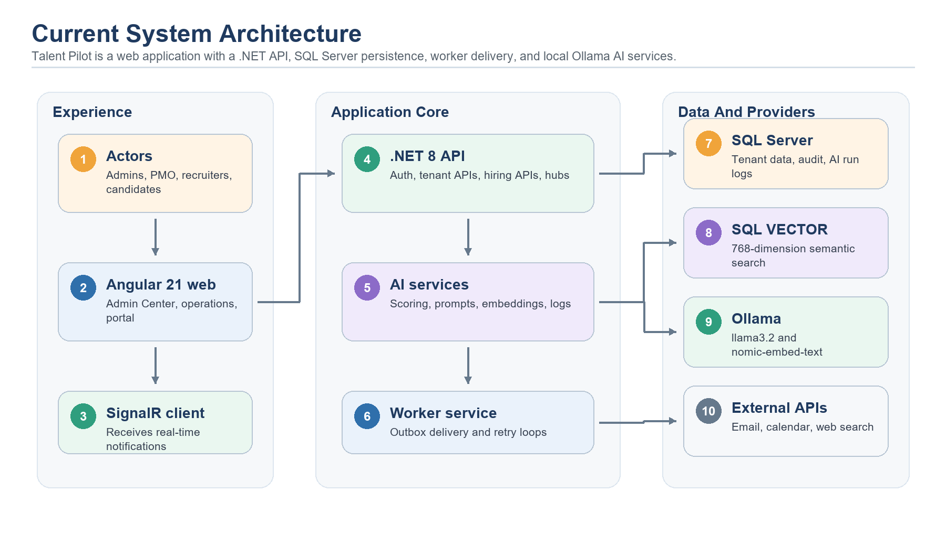
Diagram: current high-level architecture.
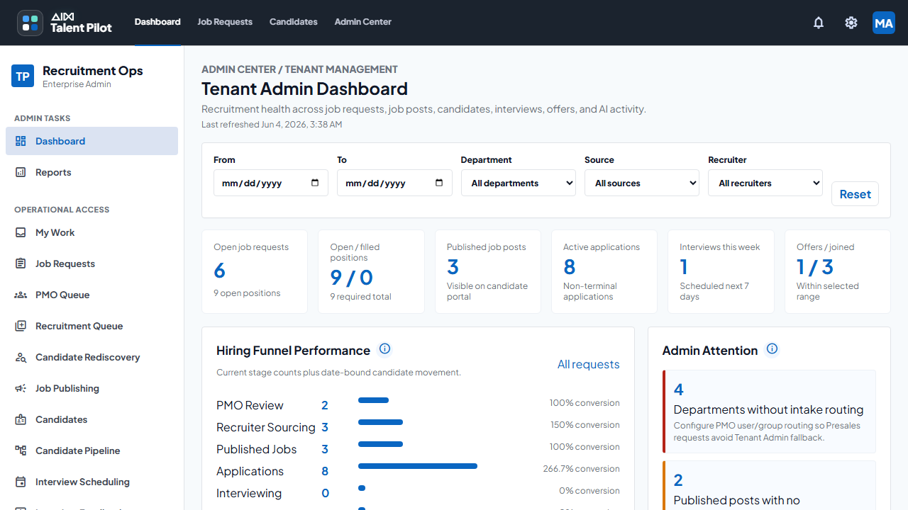
Live screenshot: Tenant Admin dashboard captured from the current running application.

Tech Stack And Runtime
Section summary
- Frontend is Angular 21 with Angular Material/CDK, RxJS, SignalR client, and Chart.js.
- Backend is .NET 8 ASP.NET Core with Clean Architecture style projects.
- SQL Server is the operational database and vector store.
- Dapper is used for explicit SQL data access.
- A .NET worker processes the notification outbox.
- Current AI runtime uses Ollama with llama3.2 and nomic-embed-text.
- External providers support email, calendar, carefully limited public web research, and lead-only GitHub candidate discovery.

Layer | Technology | Purpose
Frontend | Angular 21, Angular Material/CDK, RxJS, SignalR client, Chart.js | Runs the Admin Center, operations screens, dashboards, and candidate portal.
Backend API | .NET 8 ASP.NET Core | Owns authentication, tenant isolation, hiring APIs, workflow APIs, SignalR hub, and AI orchestration endpoints.
Data access | Dapper with Microsoft.Data.SqlClient | Keeps SQL explicit and predictable for the MVP while avoiding heavyweight ORM behavior.
Database | SQL Server | Stores tenant data, hiring entities, users, roles, notifications, audit logs, AI logs, and vectors.
Vector search | SQL Server VECTOR(768) | Stores embeddings and performs cosine-distance semantic retrieval inside the tenant boundary.
Worker | .NET worker service | Polls the notification outbox every 30 seconds and sends email provider messages with retry state.
Realtime | SignalR | Delivers in-app notifications to tenant and user recipient groups.
AI runtime | Ollama, llama3.2, nomic-embed-text | Provides local LLM generation and embeddings in the current runtime profile.
Email | Resend and Microsoft Graph | Configurable notification email providers; secrets are externalized.
Calendar | Google Calendar API | Supports interview scheduling and Meet-style calendar integration through OAuth tokens.
Search | Tavily or Google Custom Search, plus GitHub API | Used for controlled public web research and lead-only Online Headhunting. Provider secrets stay outside documentation.

Runtime Configuration
The backend runtime settings define the AI provider mode, LLM model, embedding model, embedding dimensions, vector store, search provider limits, token lifetimes, and notification providers. Secret values are not documented here and should stay in environment variables, user-secrets, deployment secret stores, or equivalent infrastructure.
- Access token lifetime is configured as 60 minutes in the current development settings.
- Refresh token lifetime is configured as 7 days.
- Current LLM model is llama3.2 through Ollama.
- Current embedding model is nomic-embed-text with 768 dimensions.
- VectorStore is configured as SqlServerVector.
- Tavily or Google Custom Search can provide controlled public web research; GitHub API can provide public developer profile search for Online Headhunting.
- Google Calendar and notification email providers are configurable and can vary by environment.

Diagram: runtime components and provider boundaries.

Authentication, Tenancy, And Authorization
Section summary
- Authentication uses email/password, BCrypt verification, JWT access tokens, and rotating refresh tokens.
- Frontend stores tokens in localStorage when 'keep signed in' is used, otherwise sessionStorage.
- Angular interceptor adds the bearer token and attempts refresh after unauthorized API responses.
- SignalR receives the access token through the hub query string during connection setup.
- JWT claims carry tenant id, user identity, role codes, and permission values.
- Roles grant permissions. Groups route work. Tenant boundaries isolate data and configuration.
- Roadmap improvements should move refresh tokens to stronger browser storage patterns and add enterprise SSO.

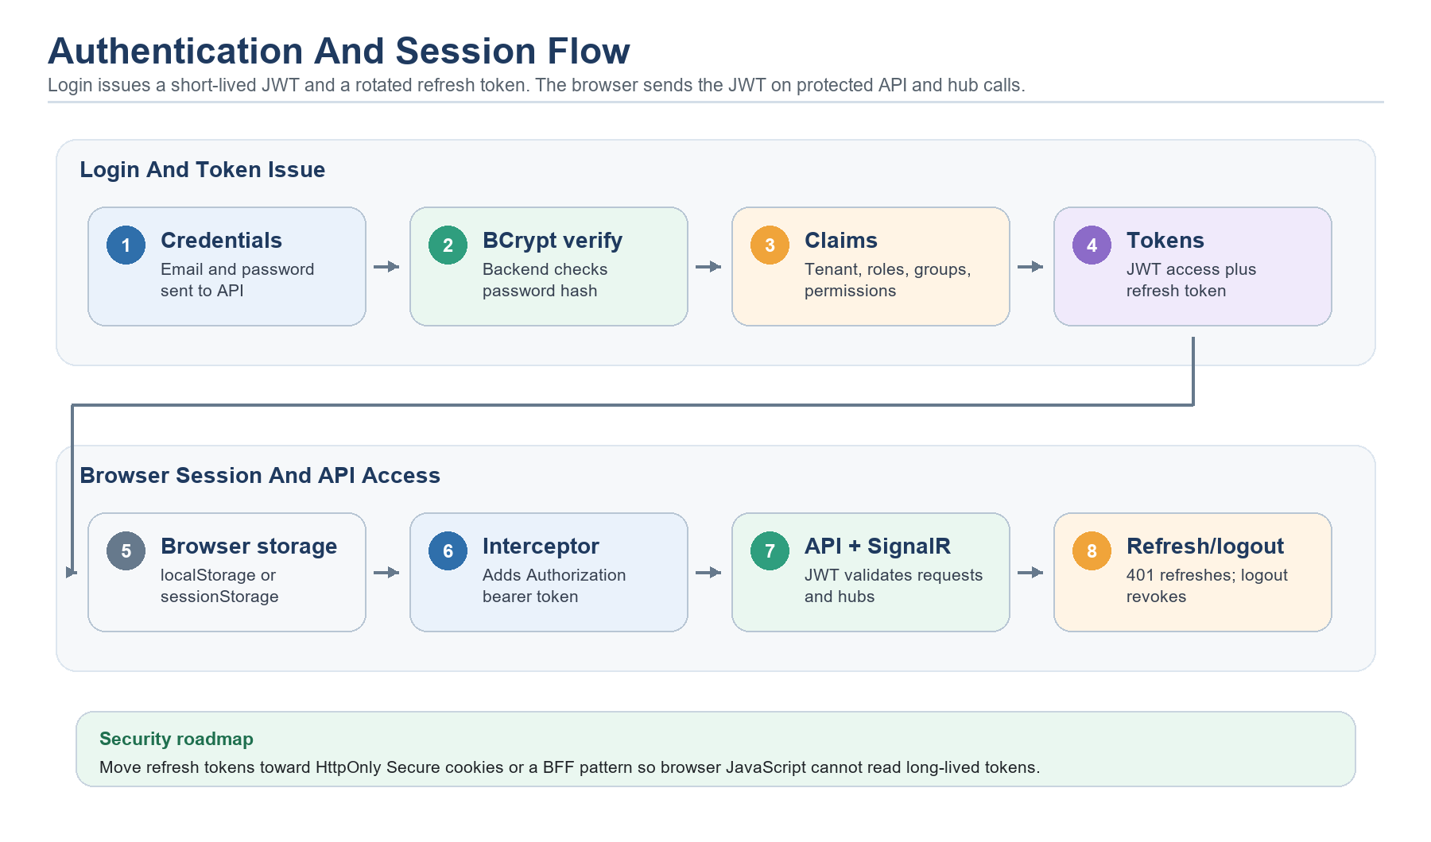
Diagram: implemented authentication and session flow.

How Login Works
- The user enters email and password on the Angular login screen.
- The API finds the user and rejects disabled accounts.
- The backend verifies the password using BCrypt.
- The backend resolves tenant, roles, permissions, and group context.
- The API issues a short-lived JWT access token and a random refresh token.
- The refresh token is hashed before storage in the database.
- On refresh, the old refresh token is revoked and a new refresh token is issued.
- Logout revokes the refresh token and clears browser-side session state.

Authentication Libraries And Frameworks
Authentication uses a mix of backend security libraries and frontend session helpers. BCrypt is a backend password-hashing library; it is not a frontend framework and it is not used to encrypt browser tokens.
Library or framework | Frontend or backend? | What it does in Talent Pilot
BCrypt.Net-Next | Backend | Hashes passwords and verifies login passwords. The database stores a BCrypt password hash, not the plain password. During login, the backend compares the submitted password with the stored hash.
Microsoft.AspNetCore.Authentication.JwtBearer | Backend | Validates JWT access tokens on API requests and rejects requests with missing, expired, or invalid bearer tokens.
System.IdentityModel.Tokens.Jwt | Backend | Creates signed JWT access tokens with claims such as user id, tenant id, roles, and permissions.
Angular AuthService | Frontend | Stores the current user, access token, refresh token, and expiry metadata in localStorage or sessionStorage based on the login choice.
Angular HTTP interceptor | Frontend | Adds the Authorization: Bearer token header to API calls and attempts token refresh when the API returns unauthorized.
SignalR | Frontend and backend | Connects the browser to the backend notification hub. The browser passes the access token during hub connection and the backend validates it.

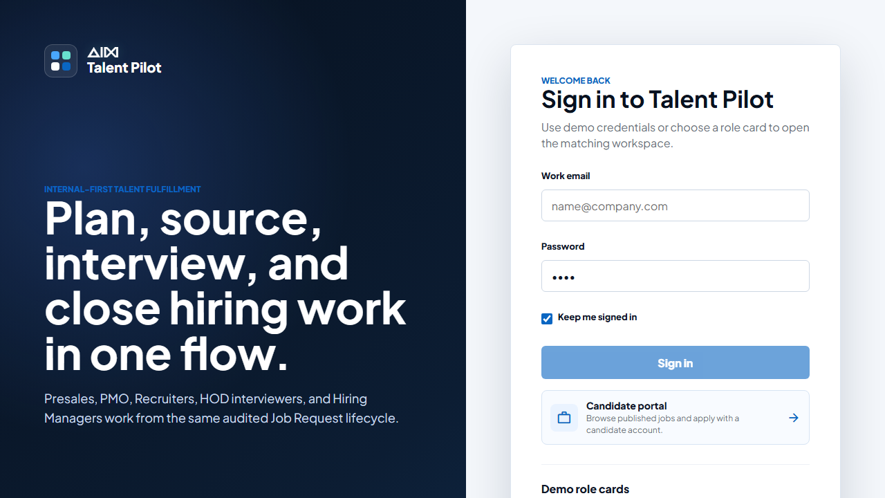
Live screenshot: current login screen.

Token Storage And Frontend Flow
Item | Current behavior | Risk or note
Access token | Stored by AuthService under talent-pilot.auth.access-token. | Readable by browser JavaScript, so XSS protection matters.
Refresh token | Stored under talent-pilot.auth.refresh-token and rotated by API. | Roadmap should consider an HttpOnly Secure cookie or Backend For Frontend (BFF) pattern.
Current user | Stored as serialized user context with roles and permissions. | Used for UI guards; backend remains final authority.
Storage choice | localStorage for keep-signed-in, sessionStorage otherwise. | Session storage reduces persistence but is still script-readable.
API requests | Angular interceptor adds Authorization: Bearer token. | Login and refresh endpoints are excluded from bearer injection.
SignalR | Hub receives access_token query value for notification connection. | Backend validates the same JWT claims.

Tenant Isolation
Tenant isolation is a product boundary and a database boundary. Core records include TenantId so users, roles, workflows, candidates, applications, notifications, audit logs, AI settings, and vectors are scoped to one organization. Tenant profile settings define default behavior such as recruitment settings, candidate login requirements, CV format expectations, public job visibility, invite expiry, notification provider, branding, timezone, and locale-sensitive defaults.
This matters because the same platform can serve more than one organization without mixing users, candidates, job data, AI vectors, audit events, or workflow routing. Tenant-specific settings also let one organization tune candidate experience and hiring workflow without changing another tenant.

Authorization Model
Area | Permission examples
Admin and access | access.admin.manage, access.users.manage, access.roles.manage, tenant.profile.manage, audit.logs.view
AI and notifications | ai.settings.view, notifications.manage
Hiring operations | job.requests.view, job.requests.create, workflow.assignments.claim, bench.matches.view
Candidate and interviews | candidates.manage, interviews.manage, hiring.decisions.manage

Role | Typical purpose
TenantAdmin | Administration across tenant settings, users, roles, workflows, AI settings, and audit visibility.
Presales | Creates job requests and provides customer/project context.
PMO | Reviews job requests, assigns work, coordinates fulfillment, and tracks workflow status.
Recruiter | Sources candidates, publishes jobs, manages applications, and drives interview scheduling.
HiringManager | Reviews shortlists, interview feedback, and final hiring recommendations.
HOD | Provides department-level ownership and approval context.
Interviewer | Participates in interviews and submits feedback.
Employee | Represents internal employees who may be matched from the bench.
Candidate | Uses the candidate portal to apply, manage profile, and view application progress.

Groups route work; permissions grant access. A group membership should not be treated as authorization by itself.

Future Authentication Improvements
- Move refresh tokens to HttpOnly Secure SameSite cookies or a Backend For Frontend (BFF) session pattern.
- Add enterprise OIDC/SSO providers such as Microsoft Entra ID where customer deployments need it.
- Strengthen production key management for JWT signing keys and token protection secrets.
- Add richer session management, device visibility, and user-driven session revocation.
- Audit authentication events such as login success, failed login, refresh, logout, lockout, and suspicious activity.

Core Hiring Flows
Section summary
- The core flow starts with a job request and ends with fulfillment closure.
- PMO review turns demand into controlled workflow work.
- Bench matching tries internal fulfillment before or alongside external sourcing.
- Recruiters publish jobs, source candidates, and manage applications.
- Candidates apply through the portal after login.
- Interview rounds, manager review, offers, outcomes, and status history create the audit trail.

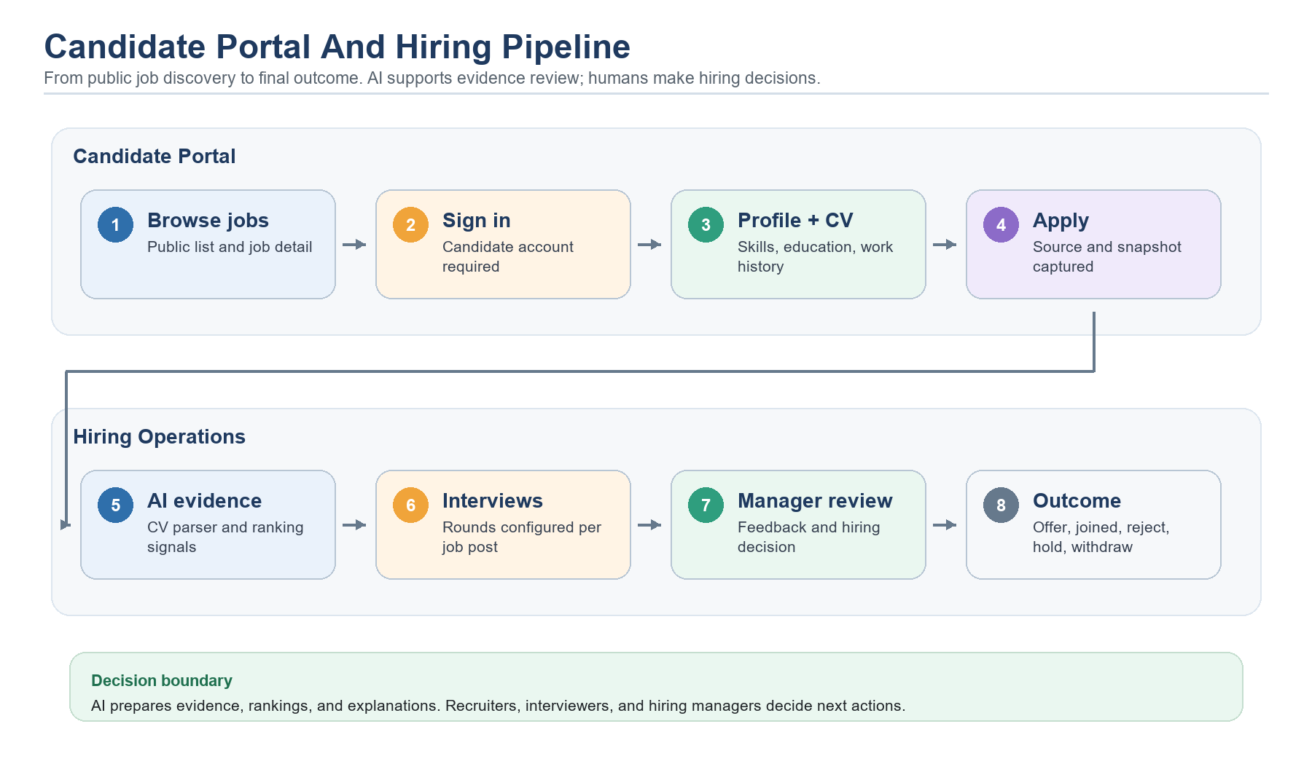
Diagram: candidate and hiring pipeline from public job to outcome.

End-To-End Flow
- Presales or PMO creates a job request with role, skills, experience, location, client/project context, and fulfillment need.
- Workflow routing uses department intake rules to place the request into the correct PMO queue or group.
- PMO reviews the request, confirms ownership, and moves it through allowed workflow actions.
- Bench Matching Agent compares the request to internal employee evidence and returns ranked recommendations.
- If internal fulfillment is not enough, recruiters source candidates and publish job posts.
- Candidates browse public jobs, log in before applying, and submit profile and application data.
- CV Parser extracts structured evidence from uploaded DOCX CVs.
- Applicant Ranking Agent helps compare applicants for the specific job post.
- Interview rounds are scheduled based on templates or job-post-specific rounds.
- Interviewers submit feedback and hiring managers review evidence.
- Recruiters and managers record offer, hold, reject, withdraw, join, or close outcomes.
- Status history, workflow history, AI logs, audit logs, and notifications preserve the operational record.

Why This Flow Helps Hiring
The flow gives every participant a clear place in the process. PMO controls fulfillment routing, recruiters control candidate sourcing, interviewers provide evidence, and hiring managers make final decisions. AI reduces manual reading and comparison work, but the application keeps sensitive decisions in human-controlled workflow steps.
The system is built for decision support, not automatic hiring decisions.

Admin Center Modules
Section summary
- Admin Center configures the tenant, users, roles, groups, departments, skills, workflows, hiring pipeline, notifications, AI, integrations, sources, and audits.
- Tenant settings are useful because each organization can keep its own branding, defaults, routing, and recruitment policies.
- Roles and permissions control access, while groups route work to teams.
- Skills and departments normalize data used by workflow and AI matching.
- AI settings expose the current model/runtime posture without exposing secrets.
- Audit logs and outbox modules give administrators operational visibility.

Module | Information stored or shown | Why it matters
Tenant Profile | Tenant name, domain, country, timezone, branding, recruitment defaults | Sets the business boundary and defaults used across the hiring flow.
Users | App users, credentials, status, tenant membership | Controls who can enter the system and participate in workflows.
Roles & Permissions | Role catalog, permission assignments, role priorities | Defines what users are allowed to view and change.
Groups | Group membership for routing | Routes work to teams without granting extra permissions by itself.
Departments | Department list and ownership context | Feeds intake routing and hiring organization structure.
Skills | Canonical skill catalog | Normalizes job requirements, CV parsing, candidate matching, and AI scores.
Hiring Pipeline | Interview templates and rounds | Creates reusable interview structures that can be copied to job posts.
Workflows | Department intake routing, read-only system stages and actions | Controls where job requests land and shows allowed transitions.
Notifications | Events, templates, recipient rules | Defines how users and candidates are informed.
Email Outbox | Pending, sent, failed provider messages | Gives operations visibility into notification delivery.
AI Settings | Provider mode, LLM, embedding model, vector store, guardrails, agent status | Central control panel for AI behavior and readiness.
Integrations | Provider configurations | Tracks external systems used for email, calendar, search, and AI runtime.
Candidate Sources | Source labels and source metadata | Improves reporting on where applicants came from.
Audit Logs | Actor, event, entity, timestamp, metadata | Provides accountability and future analytics input.

Tenant Configuration
Tenant configuration exists because Talent Pilot is multi-tenant. A tenant represents an organization using the platform. Tenant data includes identity, profile, branding, timezone, recruitment settings, candidate portal settings, notification provider choices, AI settings, access policies, and tenant-scoped hiring data. This makes the product configurable without creating separate codebases for each customer.
The benefit is operational separation. A tenant can have its own users, roles, groups, workflows, candidate sources, AI settings, outbox, audit logs, and vectors. TenantId appears throughout the data model to prevent accidental cross-organization access.

Hiring Pipeline Configuration
The hiring pipeline module stores interview templates and rounds. A template can define round names, default owner role or user, duration, required status, and sequence. Job posts can then use configurable rounds that fit the role. This keeps the process consistent while still allowing job-specific changes when a role needs a different interview plan.

Workflow Configuration
The workflows module currently exposes department intake routing and system workflow information. Department routing decides which PMO group or owner should receive a Presales-created job request. System stages, transitions, and actions are displayed as guardrails because the product needs predictable state movement and should not allow unsafe runtime editing of every transition without a stronger rules engine.

AI Agents, LLMs, Embeddings, And RAG
Section summary
- The application exposes eleven active AI agent definitions in Admin Center, including Fit Explanation, Online Headhunting, Conversational RAG, and Interview Question Recommender.
- Current LLM provider is Ollama with llama3.2.
- Current embedding provider is Ollama nomic-embed-text with 768-dimensional vectors.
- Agents prepare evidence with code, embeddings, vector search, retrieval, and approved external providers.
- CV parsing extracts DOCX text locally, then requires the LLM to return strict JSON fields and a recruiter-facing summary.
- The C# agent services are the orchestration brain; the LLM writes generated summaries, explanations, RAG answers, drafts, enrichment, and interview question sets.
- Ranking agents fail closed if the LLM does not return usable explanations; code-built fallback explanations are no longer used.
- Online Headhunting is lead-only and human-reviewed; current code can return provisional search/scoring leads if LLM enrichment fails.
- The agents are not self-improving today; feedback must be used by the team to tune prompts, weights, and tests.
- AI outputs are advisory and should be tuned with outcome feedback, regression tests, and prompt/version tracking.
- Changing an LLM affects generated wording, explanations, RAG answers, and interview questions; changing an embedding model requires vector reindexing.

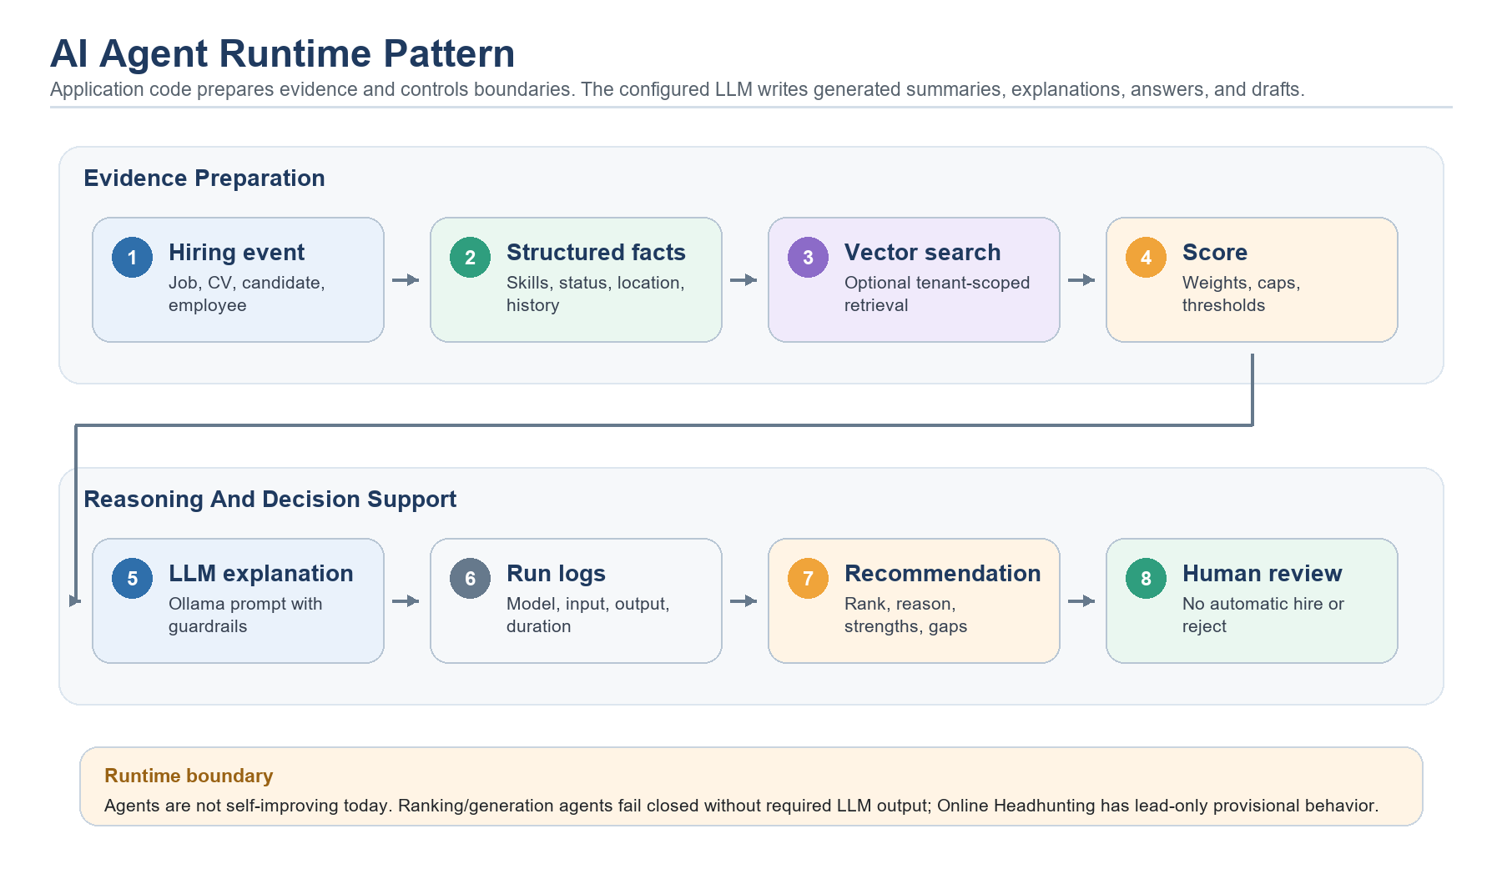
Diagram: AI agent runtime pattern.

Verified Current Behavior: LLM Use And Fail-Closed Boundaries
The current code confirms that deterministic fallback explanations have been removed from the ranking agents. Code still prepares evidence, vectors, filters, and score components, but Bench Matching, Talent Rediscovery, Applicant Ranking, CV Parser, RAG answers, and Interview Question Recommender require successful LLM output where the feature generates language or structured recommendations.
- Job Description Drafting fails if the LLM returns empty text or the model call fails.
- CV Parser extracts DOCX text locally, then requires the LLM to return valid CV JSON and a summary.
- Bench Matching, Talent Rediscovery, and Applicant Ranking prepare scores first, then fail closed if the LLM does not return usable explanations for the ranked records.
- Online Headhunting is the exception: it discovers leads with approved search providers and code scoring, then asks the LLM to enrich fit summaries, gaps, duplicate notes, and outreach drafts. Current code catches enrichment failure and can still return provisional lead-only results.
- Conversational RAG can return system safety/no-evidence messages without generation, but normal evidence-based answers require the LLM.
- Interview Question Recommender retrieves and ranks bank items first, then fails closed unless the LLM returns valid strict JSON after the repair attempt.
- Requirement Parser is an embedding/indexing helper rather than a generative user-facing AI agent; its indexing failure is logged and does not block job request creation.

How The Agents Work
The agents are defined in backend application and infrastructure services. Dependency injection wires the main services for job description drafting, CV parsing, bench matching, talent rediscovery, Online Headhunting, applicant ranking, the conversational RAG assistant, and the interview question recommender. Requirement parsing is a static extraction/indexing capability. Fit Explanation is registered as an advisory definition for explaining ranking evidence. Decision brief behavior is advisory and based on the evidence already collected by the system.
The design intentionally separates evidence preparation, scoring, retrieval, provider calls, and LLM output. Evidence comes from structured database records, parsed documents, vector search, and controlled external providers where allowed. Code calculates scores, applies caps or filters, and prepares prompts. Most generated outputs fail closed when the LLM response is missing or invalid. Online Headhunting currently treats LLM enrichment as an enhancement over lead discovery rather than a hard gate.
AI agents must not approve, reject, contact candidates, change workflow stages, or make final hiring decisions.

What Is The Brain Of The Agents?
The LLM is the language and reasoning brain for generated user-facing text. The application code is the orchestration brain: it decides what evidence to gather, which tools to call, how to score evidence, how to build prompts, how to validate model responses, and what to log. The LLM writes the draft, summary, explanation, RAG answer, outreach enrichment, or structured question set. It does not directly query the database, change workflow state, or decide hiring outcomes.
- C# service code is the controller: it owns the flow, scoring formulas, caps, filters, prompt assembly, response validation, and fail-closed behavior.
- SQL Server is the memory: it stores jobs, candidates, applications, employees, AI runs, recommendations, audit logs, and vectors.
- Embeddings and SQL VECTOR are the semantic memory: they find records with similar meaning, not just exact keywords.
- Prompts are the behavior instructions: they tell the LLM what to parse, explain, draft, answer, or generate, and what it must not do.
- Runtime settings are the control panel: they define model names, embedding model, dimensions, vector store, and provider mode.
- Tests are the guardrail contract: they prove agents respect boundaries such as no web search for rediscovery and no personal data in bench-search queries.
Simplified internal agent flow
// Simplified current pattern used by ranking agents
settings = runtimeSettings.GetCurrent();
runId = aiRunLogger.Start(agentId, model, embeddingModel, inputHash);
vectorScores = TryBuildVectorScores(evidence);
scored = evidence.Select(item => ScoreWithRules(item, vectorScores));
explanations = GenerateLlmExplanations(scored);
if (scored.Any() && explanations.Count == 0)
throw InvalidOperationException("No usable LLM explanations returned.");
ranked = scored.Select(item => UseRequiredLlmExplanation(item));
aiRunLogger.Succeed(runId, model, embeddingStatus);
return ranked;

LLM Dependency And Fail-Closed Behavior
AI capability | LLM usage | Can produce user-facing AI output without LLM? | What happens
Job Description Drafting | LLM is the main writer. | No. | The agent logs failure and returns an error because the draft itself requires generation.
CV Parser | LLM parses extracted DOCX text into strict JSON and writes the recruiter-facing summary. | No. | The agent can extract DOCX text locally, but it fails if the LLM is unavailable, returns invalid JSON, or omits required summary output.
Bench Matching | LLM explains already-scored employee matches. | No. | Code can prepare scores and vectors first, but the agent throws and logs failure if usable LLM explanations are not returned.
Talent Rediscovery | LLM explains already-scored warm candidates. | No. | Code can prepare scores and filters first, but the agent throws and logs failure if usable LLM explanations are not returned.
Online Headhunting | LLM enriches discovered leads with fit summary, strengths, gaps, duplicate explanation, and outreach draft after approved source search and code scoring. | Yes, for provisional lead-only results today. | Search/GitHub providers and code scoring can still return persisted lead-only results if LLM enrichment fails. No candidates, applications, messages, or workflow actions are created automatically.
Applicant Ranking | LLM explains already-scored current applications. | No. | Code can prepare scores and document evidence first, but the agent throws and logs failure if usable LLM explanations are not returned.
Requirement Parser | No LLM output; this is an embedding/indexing helper rather than a user-facing generative agent. | Not applicable. | Job request save continues if requirement embedding fails; the indexing run is logged for follow-up.
Fit Explanation | LLM-generated ranking explanations are produced inside Bench Matching, Talent Rediscovery, and Applicant Ranking runs. | No. | The seeded definition describes the explanation contract. Ranking agents fail closed when required LLM explanations are missing.
Decision Brief / Explainability | Decision brief currently presents stored evidence; ranking explanations now require LLM output in their owning agents. | Partly. | Stored hiring review evidence can still be displayed, but agent-generated ranking explanations fail closed without LLM output.
Conversational RAG Assistant | LLM generates the final cited answer after vector retrieval. | No. | It can retrieve evidence first, but without the LLM it returns a runtime-unavailable message instead of a synthesized answer.
Interview Question Recommender | LLM generates the final strict JSON question set after question-bank retrieval and vector ranking. | No. | It can rank bank items first, but no recommendation set is saved unless the LLM returns valid structured output.

Are These Self-Improving Agents?
No. The current agents do not retrain themselves, rewrite their own prompts, change scoring weights, or learn automatically from user behavior. They record inputs, model names, outputs, scores, status, and recommendation evidence. That recorded data can support future tuning, but a human/product/engineering process must decide which prompt, weight, model, or rule should change.
Current state: logged and tunable, but not self-improving. Future state: use feedback loops and evaluation sets to improve safely.

Areas That Can Benefit From More AI Agents
Talent Pilot already has useful agent foundations: structured hiring data, workflow history, audit logs, AI run logs, embeddings, vector search, and human review screens. The next agents should focus on reducing coordination work, improving evidence quality, and surfacing risks earlier. They should stay advisory unless a human explicitly confirms an action.
Recommended rule for future agents: draft, detect, explain, recommend, and summarize; do not silently approve, reject, contact, schedule, or move workflow state.

Conversational RAG Assistant Expansion (High priority)
- Purpose: Expand the implemented conversational assistant into more hiring contexts and richer cited operational answers.
- Tools/evidence: Existing AiAssistantService, KnowledgeIndexingService, KnowledgeRetrievalService, VectorEmbeddings, CV extracted text, job descriptions, workflow history, audit logs, AI recommendation logs, and LLM response generation.
- Benefit: Gives PMO, recruiters, hiring managers, and admins a broader natural-language way to understand why something happened or what evidence exists.
- Guardrails: Tenant and permission filters must apply before retrieval; answers should cite sources and say when evidence is missing.

Job Intake Quality Agent (High priority)
- Purpose: Review job requests before PMO work starts and flag missing, vague, or conflicting details.
- Tools/evidence: Job request fields, department rules, skills catalog, historical job requests, hiring pipeline templates, and LLM rewriting.
- Benefit: Improves intake quality, reduces back-and-forth with Presales, and gives PMO clearer requirements earlier.
- Guardrails: It can suggest clarifying questions and draft cleaner wording, but it should not block submission without configurable rules.

Skill Taxonomy And Normalization Agent (High priority)
- Purpose: Detect duplicate, inconsistent, misspelled, or overly broad skills and suggest canonical mappings.
- Tools/evidence: Skills table, CV parser output, job request skills, candidate skills, embedding similarity, and admin approval workflow.
- Benefit: Improves matching quality because Bench Matching, Rediscovery, and Applicant Ranking all depend on clean skill evidence.
- Guardrails: Suggested merges should require admin approval; the agent should preserve original user-entered terms for auditability.

Interview Question Recommender Expansion (High priority)
- Purpose: Expand the implemented Interview Question Recommender with editable tenant bank management, more round-specific rubrics, and feedback-driven quality reports.
- Tools/evidence: InterviewQuestionBankItems, recommendation sets, generated questions, interview feedback, skills catalog, job post requirements, document evidence, and LLM output quality logs.
- Benefit: Improves consistency across interviewers and lets leadership see which generated questions produce useful hiring signal.
- Guardrails: Generated questions should remain advisory, should be reviewed by humans, and should avoid discriminatory, personal, or legally sensitive topics.

Interview Feedback Synthesizer Agent (High priority)
- Purpose: Summarize interview feedback, detect disagreement between interviewers, and highlight missing evidence before hiring-manager review.
- Tools/evidence: Interview feedback, score fields, recommendations, round status, candidate profile, and job requirements.
- Benefit: Helps hiring managers see signal, gaps, and contradictions quickly without reading every feedback note manually.
- Guardrails: It should summarize evidence only; it must not decide hire/no-hire or override interviewer recommendations.

Workflow Bottleneck And SLA Agent (Medium priority)
- Purpose: Detect job requests, applications, interviews, offers, or notifications that are at risk of delay.
- Tools/evidence: WorkflowHistory, status history, assignments, notification outbox, interviews, offer status, and historical time-in-stage metrics.
- Benefit: Allows PMO and recruiters to act before fulfillment slips instead of discovering delays late.
- Guardrails: Recommendations should be explainable and should not auto-reassign work unless a configured automation rule allows it.

Candidate Engagement Drafting Agent (Medium priority)
- Purpose: Draft personalized but policy-safe candidate emails for follow-ups, interview reminders, status updates, and re-engagement.
- Tools/evidence: Candidate profile, application status, job post, notification templates, interview schedule, and LLM drafting.
- Benefit: Improves candidate experience and reduces recruiter writing effort.
- Guardrails: Human review should be required before sending; templates should prevent promises, compensation commitments, or sensitive explanations.

Source Quality And Market Intelligence Agent (Medium priority)
- Purpose: Analyze candidate sources, skills demand, response rates, conversion, and role trends across tenant data.
- Tools/evidence: Candidate source labels, job posts, application outcomes, status history, skills, locations, and privacy-safe aggregate analytics.
- Benefit: Helps leadership decide which sources work, which skills are hard to hire, and where market demand is moving.
- Guardrails: Reports should be aggregate and tenant-scoped; personal candidate details should not be exposed in trend analysis.

Online Lead Verification And Compliance Agent (Medium priority)
- Purpose: Review Online Headhunting leads for source quality, duplicate risk, missing contact evidence, outreach suitability, and policy concerns before recruiters convert them.
- Tools/evidence: OnlineCandidateSourcingRuns, OnlineCandidateLeads, source status, duplicate status, candidate pool identifiers, lead outcome status, outreach drafts, and source conversion history.
- Benefit: Improves trust in headhunting results and helps recruiters focus on leads that are both relevant and appropriate to contact.
- Guardrails: It should stay advisory, should not scrape restricted pages, should not enrich private contact data without an approved provider, and should require recruiter confirmation before outreach or conversion.

Admin Configuration Auditor Agent (Medium priority)
- Purpose: Find risky or incomplete tenant setup such as missing routing rules, inactive notification templates, weak role permissions, or stale AI settings.
- Tools/evidence: Admin configuration tables, roles/permissions, groups, departments, workflows, notifications, integrations, AI settings, and audit logs.
- Benefit: Reduces production setup mistakes and gives admins a checklist of configuration risks.
- Guardrails: It should explain risk and suggest fixes; it should not change permissions, providers, or routing without admin approval.

Data Quality And Duplicate Candidate Agent (Medium priority)
- Purpose: Find duplicate candidates, stale profiles, missing contact fields, inconsistent experience values, and low-quality CV parse results.
- Tools/evidence: Candidate profile fields, email/phone matching, CV parsed fields, application history, source labels, and vector similarity.
- Benefit: Improves recruiter trust in search, ranking, rediscovery, and reporting.
- Guardrails: Merges and deletes should always require human review because candidate records are sensitive.

Offer And Policy Consistency Agent (Later priority)
- Purpose: Review offer drafts and presentation notes for missing terms, inconsistent dates, or policy-sensitive wording.
- Tools/evidence: Offer letter details, compensation text, start date, reporting manager, role, location, and approved offer templates.
- Benefit: Reduces offer-document errors and makes handoff from hiring decision to offer smoother.
- Guardrails: It should not approve compensation or issue offers; it should only flag risks and draft corrections for authorized users.

AI Operations And Reindexing Agent (Later priority)
- Purpose: Monitor AI runtime health, embedding status, vector freshness, model changes, and records that need reindexing.
- Tools/evidence: AiAgentRuns, VectorEmbeddings, runtime settings, embedding model/version, source text hashes, and health check results.
- Benefit: Makes model changes safer and helps admins know when semantic search quality may be degraded.
- Guardrails: It should recommend reindexing and show impact; actual reindex jobs should be explicit admin actions with progress and rollback visibility.

Agent Deep Dive

Job Description Drafting Agent
Purpose: turns structured job request fields into an editable job description draft. It is used when the team wants a faster first draft, not a final approved job post.
- Tools used: IAiModelProvider/Ollama for text generation, IAiRuntimeSettingsResolver for model selection, AiTextHasher for input hashing, and IAiAgentRunLogger for auditability.
- Why these tools: the LLM is useful for writing readable text; hashing and logging make each run traceable without storing secrets in the document.
- LLM usage: the prompt tells the model to use only structured fields and ignore prompt-injection instructions inside job fields.
- Fallback: if the LLM is offline or returns empty text, the agent fails and logs the failure because this agent's core output is generated text.
- Improvement path: add output schema checks, golden examples by role family, prompt versioning, tone presets, and reviewer feedback on accepted versus edited drafts.

CV Parser Agent
Purpose: extracts candidate facts from uploaded DOCX CV files so recruiters do not manually retype basic profile data.
- Tools used: DOCX ZIP/OpenXML reader for text extraction, LLM model provider for strict JSON parsing, runtime settings resolver, and AI run logger.
- Why these tools: local DOCX extraction gets readable text from word/document.xml, then the LLM handles flexible resume interpretation that is difficult to maintain with regex-only parsing.
- LLM usage: required. The parser prompts the LLM to return strict JSON with display name, email, phone, current role/company, experience, skills, university, degree, graduation year, and summary.
- Summary behavior: the recruiter-facing CV summary now comes from the LLM response and is required; missing summary output fails the parse.
- Vector relationship: after parsed CV evidence is attached to an application, the application builds a labeled evidence text profile that includes the CV parser summary and extracted CV text, then sends that text to the embedding provider for vector storage.
- Failure behavior: it fails if the file is empty, not DOCX, text cannot be extracted, the LLM is unavailable, the LLM returns invalid JSON, or required fields such as summary are missing.
- Improvement path: support PDF, expand the skill taxonomy, add section-aware parsing, add confidence per field, add OCR/document intelligence, and add evaluation sets for resume formats.
Current CV parser and vector indexing relationship
// Simplified current CV parser behavior
text = ExtractDocxText(fileBytes); // reads word/document.xml
if (string.IsNullOrWhiteSpace(text))
throw InvalidOperationException("CV parser could not extract text.");
json = Llm.Generate(BuildCvParserPrompt(text, fileName));
parsed = JsonSerializer.Deserialize<AiCvParseResponse>(json);
summary = RequiredText(parsed.Summary, "summary");
skills = CleanList(parsed.Skills);
// Later, when parsed CV evidence is saved with an application
evidenceText =
"CV Parser Agent summary: " + summary +
"Extracted CV text: " + text;
embedding = embeddingProvider.GenerateEmbeddingAsync(evidenceText);
VectorEmbeddings.Upsert(JobApplication, JobApplicationEvidenceProfile, embedding);

Bench Matching Agent
Purpose: ranks eligible internal employees for a job request so PMO can evaluate bench fulfillment before or alongside external sourcing.
- Tools used: job request and employee evidence from the operations context, embedding provider, SQL vector store, optional web research provider, LLM model provider, runtime settings resolver, and AI run logger.
- Why embeddings/vector search: exact skill matches are not enough; semantic similarity helps compare job descriptions and employee profiles even when wording differs.
- Why web research: only safe public client/project context may improve relevance for client/project fit. Tests verify employee personal names and emails are not sent to search.
- LLM usage: required after code scores employees. The LLM must return recruiter/PMO-facing explanations in JSON for the ranked employees. It does not calculate the numeric score.
- Failure behavior: if embeddings fail, vector similarity becomes empty and rule scoring can still prepare candidates. If web research fails, status becomes skipped/unavailable. If the LLM fails or omits explanations, the whole agent run fails closed and no fallback explanation is returned.
- Improvement path: calibrate score weights using referral outcomes, add per-department thresholds, review web-search query templates, add bias/drift checks, and make explanation quality part of evaluation.

Talent Rediscovery Agent
Purpose: finds previous warm candidates who may fit a new job, using their profile, past applications, interview feedback, outcomes, and semantic similarity.
- Tools used: candidate/application/interview evidence, embedding provider, SQL vector store, LLM model provider, runtime settings resolver, and AI run logger.
- Why no web research: rediscovery is based on internal candidate history. Sending candidate personal data to public search would be unnecessary and unsafe.
- LLM usage: required after score preparation. The LLM explains ranked candidates in JSON. Prompt guardrails say not to search the web and not to decide whether to contact the candidate.
- Failure behavior: if embeddings fail, semantic status is logged and score preparation continues without vector contribution. If the LLM is unavailable or returns no usable explanations, the agent run fails closed.
- Hard boundary: candidates with Joined or Hired outcomes are filtered out. Weak skill coverage is capped so old history cannot overpower missing current fit.
- Improvement path: tune warm-candidate boost with actual reactivation outcomes, add stale-profile detection, add consent/retention rules, and create evaluation sets for rejected/hold/offer-declined histories.

Online Headhunting Agent
Purpose: discovers lead-only online candidate results for a claimed recruiter sourcing job request. It helps recruiters find potential external prospects without automatically creating candidate records, messaging people, or changing hiring workflow state.
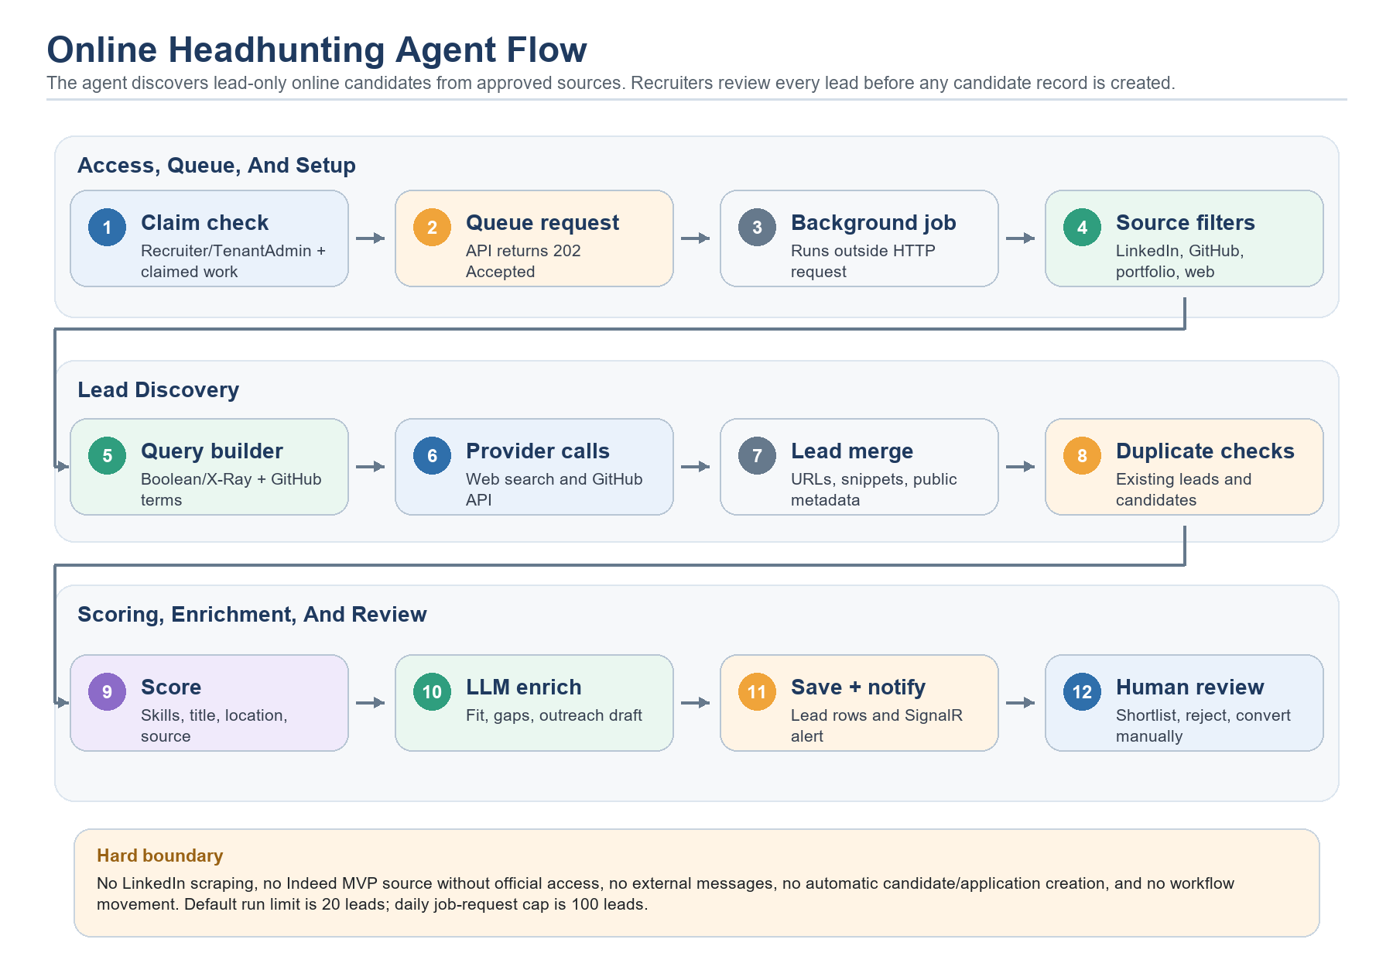
Diagram: Online Headhunting source search, enrichment, persistence, and review boundary.
- Access: Recruiter and TenantAdmin can run it. A recruiter must have claimed the Recruiter Sourcing work item before the API allows the search.
- API surface: POST /api/talent-pilot/job-requests/{jobRequestId}/online-headhunting/search queues the search and returns 202 Accepted with request metadata; PATCH /api/talent-pilot/online-headhunting/leads/{leadId}/status updates review status.
- Tools used: OnlineHeadhuntingBackgroundQueue, OnlineHeadhuntingBackgroundService, OnlineHeadhuntingBooleanQueryBuilder, IWebResearchProvider, IGitHubCandidateSearchProvider, IAiModelProvider, IAiRuntimeSettingsResolver, IAiAgentRunLogger, DapperOperationsRepository, SignalR notification publisher, and SQL tables for sourcing runs/leads.
- Approved sources: default sources are LinkedIn source links, GitHub, portfolio pages, and public search. Indeed is not an active MVP source unless an official partner/API path is added later.
- Why these tools: public search finds source links and snippets, GitHub API returns public developer profile metadata, code scoring gives consistent ranking, and the LLM improves the human-readable fit summary and outreach draft.
- Query behavior: LinkedIn uses site-limited X-Ray search through the configured search provider. Portfolio and public search use broader Boolean searches. GitHub uses API search terms rather than web X-Ray operators.
- LLM usage: the LLM enriches each lead with fit summary, strengths, gaps, duplicate explanation, and outreach draft. The prompt says to return JSON only, not invent contact data, not recommend automatic outreach, and require recruiter review.
- Current LLM boundary: enrichment failure is caught, so the agent can still return provisional lead-only results from source search and code scoring. This is different from the ranking agents that fail closed without LLM explanations.
- Persistence: OnlineCandidateSourcingRuns stores completed run metadata, model, source codes, queries, status, limits, and AI run id. OnlineCandidateLeads stores source link, profile fields, evidence snippet, score, confidence, matched skills, gaps, missing data, duplicate status, outreach draft, status, and conversion linkage if later converted.
- Limits: default/max run limit is 20 leads, and persisted leads are capped at 100 per job request per UTC day.
- Duplicate safety: the agent compares email, phone, profile URL, normalized name, role/company overlap, and skill overlap against the existing candidate pool before showing a duplicate status.
- Hard boundary: it does not scrape LinkedIn pages, use Indeed without official access, automate external platform messages, create candidates or applications, or move workflow stages. A recruiter must manually convert a lead into a candidate/application when appropriate.
- Improvement path: make LLM enrichment fail-closed if product policy requires strict LLM-only behavior, add source-quality scoring, add consent/compliance review, add duplicate confidence calibration, add lead outcome tracking, and evaluate which sources convert into interviews or hires.

Headhunting Terminology
The agent uses recruiting search terms that are common in sourcing teams. In Talent Pilot, these terms always mean lead discovery for recruiter review, not automated scraping or automated outreach.
Term | Plain-English meaning | How Talent Pilot uses it
Boolean search | A search query that combines words with operators such as OR, quotes, parentheses, and negative terms. | The query builder combines job titles, required skills, and location into repeatable search strings.
X-Ray search | Using a general search engine with site: to find public pages inside a target domain. | LinkedIn source search uses site:linkedin.com/in to find public profile links only. Talent Pilot does not log into LinkedIn or scrape profile pages.
site: operator | A search operator that limits results to a domain or path. | site:linkedin.com/in tells the search provider to return public LinkedIn profile pages instead of the wider web.
Quoted phrase | Words inside quotes are searched as a phrase. | "Senior React Developer" keeps the role title together instead of treating every word separately.
OR group | Parentheses with OR allow alternatives. | ("Senior React Developer" OR "React Developer") improves recall when people use different titles.
Negative terms | Minus-prefixed terms remove unwanted results. | -jobs, -hiring, -company, and similar filters reduce job ads, hiring pages, and company pages.
Source link | The URL, title, and snippet returned by a search provider. | The app stores source evidence for recruiter review. It does not treat a source link as a verified candidate record.
Lead-only result | A prospect found online before it becomes a Talent Pilot candidate. | OnlineCandidateLeads are reviewed as New, Shortlisted, Rejected, or later Converted by a human-controlled flow.

Toolchain Used By The Agent
Tool or service | Type | What it does | Boundary
Angular recruiter sourcing UI | Frontend | Lets recruiters choose sources, run search, review leads, copy outreach drafts, reject leads, or open manual conversion. | Cannot bypass backend claim/role checks.
OperationsService | Backend application service | Checks Recruiter/TenantAdmin access, sourcing claim ownership, run limit, and daily lead cap, then queues the background job. | Returns 202 Accepted queue metadata; does not create candidates when queueing or execution fails.
OnlineHeadhuntingBackgroundQueue / Service | Background worker | Stores the requested job in a bounded in-memory queue and executes it outside the HTTP request. | If the queue is busy, the API returns a temporary-busy error. Completion is reported by realtime notification.
OnlineHeadhuntingBooleanQueryBuilder | Backend helper | Builds LinkedIn X-Ray, portfolio, public web, and GitHub API search terms from job title, skills, and location. | Builds queries only; it does not fetch or scrape pages.
IWebResearchProvider | Search abstraction | Calls the configured provider, such as Tavily or Google Custom Search, for source links, titles, and snippets. | Search requests should avoid restricted scraping and external messaging.
IGitHubCandidateSearchProvider | GitHub API adapter | Searches public GitHub users and reads public profile metadata when GitHub is selected. | Uses public API results; private repositories or private user data are not required.
IAiModelProvider | LLM abstraction | Asks the configured LLM to enrich lead summaries, strengths, gaps, duplicate explanation, and outreach draft. | The prompt forbids invented contact data and automatic outreach.
IAiAgentRunLogger | Audit/logging service | Records agent id, model, input hash, source codes, status, lead count, and failure/success metadata. | Used for traceability, not for autonomous self-improvement.
SignalR notification publisher | Realtime delivery | Notifies the initiating user when the background run succeeds or fails and points back to the AI Headhunting tab. | Notification delivery does not change candidate or application state.
DapperOperationsRepository | SQL persistence | Saves OnlineCandidateSourcingRuns and OnlineCandidateLeads, then returns review-ready lead data. | Persists leads only; candidate/application creation is a separate manual conversion flow.

How One Search Run Works
- The recruiter opens the AI Headhunting tab inside recruiter sourcing and selects LinkedIn, GitHub, Portfolio, PublicSearch, or the default source set.
- The API verifies JWT authentication, tenant context, Recruiter or TenantAdmin access, and recruiter sourcing claim ownership.
- The service normalizes source codes. Unknown and out-of-scope values are dropped; an empty list becomes LinkedIn, GitHub, Portfolio, and PublicSearch.
- The API queues an OnlineHeadhuntingBackgroundJob and immediately returns 202 Accepted with request id, requested limit, daily lead cap/count, source codes, status Queued, and queued timestamp.
- The background service dequeues the job and re-checks access, claim context, daily cap, and normalized input before executing the actual search.
- The query builder creates Boolean/X-Ray web queries for non-GitHub sources and GitHub API search terms for GitHub.
- The web research provider returns source URLs, titles, and snippets. The GitHub provider returns public GitHub profile metadata.
- The agent removes results without source URLs, filters likely job ads/company pages, applies location-fit checks, and deduplicates by normalized source URL.
- Code scoring starts from a base lead score, adds matched-skill, title, location, and GitHub-source signals, then clamps the score between 45 and 97.
- Duplicate checking compares the lead with the internal candidate pool by email, phone, profile URL, normalized name, role/company overlap, and skill overlap.
- The LLM enriches the lead with a short fit summary, strengths, gaps, duplicate explanation, and editable outreach draft. If enrichment times out or fails, current code returns the provisional lead-only result.
- The repository saves the sourcing run and distinct new lead rows. Existing lead identity keys prevent repeated runs from duplicating the same source/contact evidence.
- The service publishes a realtime OnlineHeadhunting notification to the initiating user. The recruiter refreshes the AI Headhunting tab, then reviews, shortlists, rejects, copies outreach, opens the source URL, or manually converts the lead into a candidate/application.
Current Boolean, X-Ray, and GitHub query patterns
// Example LinkedIn X-Ray query shape
site:linkedin.com/in ("Senior React Developer" OR "React Developer")
(React OR TypeScript OR "Node.js" OR "Next.js") "Lahore"
-jobs -hiring -company
// Example portfolio/public web shape
("Senior React Developer" OR "React Developer")
(React OR TypeScript OR "Node.js" OR "Next.js") "Lahore"
(portfolio OR "personal website" OR resume OR CV)
-jobs -hiring -vacancy -apply -"job description" -"job summary"
// Example GitHub API query terms
React TypeScript Node.js Next.js location:Lahore

Simplified queued Online Headhunting flow
// Simplified current queued Online Headhunting flow
queued = SearchOnlineCandidatesAsync(jobRequestId, input);
// returns 202 Accepted with requestId, Status = "Queued", limits, source codes
backgroundService.Dequeue(job);
AuthorizeRecruiterSourcingClaim(user, job.JobRequestId);
sourceCodes = Normalize(job.Input.SourceCodes); // defaults: LinkedIn, GitHub, Portfolio, PublicSearch
queries = queryBuilder.BuildQueries(context, sourceCodes);
webResults = webResearch.Search(queries.Except(GitHub));
githubResults = githubProvider.Search(BuildGitHubQuery(context));
rawLeads = MergeAndDeduplicateBySourceUrl(webResults, githubResults);
scored = rawLeads.Select(lead =>
ScoreLead(context, lead)
.WithDuplicateStatus(CheckCandidatePool(context.CandidatePool, lead)));
// LLM enriches text, but enrichment failure currently returns the scored leads.
enriched = await EnrichLeadsAsync(context, scored, cancellationToken);
SaveOnlineCandidateSourcingRun(enriched, queries, status, aiAgentRunId);
PublishOnlineHeadhuntingNotification(requestingUser, successOrFailure);
return LeadOnlyResultForRecruiterReview(enriched); // read from recruiter sourcing refresh

Applicant Ranking Agent
Purpose: ranks current applications for an active job post so recruiters and hiring managers can review stronger applications first.
- Tools used: job post requirements, current applications, candidate profile fields, cover letter, extracted document evidence, embedding provider, SQL vector store, LLM model provider, runtime settings resolver, and AI run logger.
- Why document evidence matters: the agent can use CV/cover-letter extracted text and file evidence instead of relying only on manually entered candidate fields.
- LLM usage: required after score preparation. The LLM explains already-ranked applications. Prompt guardrails say not to search the web and not to decide whether to shortlist, hold, reject, or schedule.
- Failure behavior: if embeddings fail, it records an actionable semantic-similarity status and continues score preparation without vector contribution. If the LLM is unavailable or returns no usable explanations, the agent run fails closed.
- Hard boundary: it only ranks current applications for the job post; it must not pull employee vectors or make hiring decisions.
- Improvement path: add field-level evidence confidence, normalize CV extraction quality, tune recency and evidence-completeness weights, and compare ranking outcomes with interview/hire conversion.

Requirement Parser / Requirement Profile Indexing
Purpose: builds and stores a requirement profile embedding when a job request is saved. This makes later semantic matching faster and more consistent.
- Tools used: BuildJobRequestEmbeddingText, AiTextHasher, embedding provider, SQL vector store, runtime settings resolver, and AI run logger.
- Why these tools: the application turns controlled job request fields into a stable text profile, hashes it, embeds it, and stores it for downstream matching.
- LLM usage: none today. This is an embedding/indexing helper, not a user-facing generative AI agent.
- Failure behavior: job request creation does not fail just because requirement embedding fails; the indexing failure is logged for follow-up.
- Improvement path: add richer requirement normalization, capture must-have versus nice-to-have skill weight, reindex when embedding models change, and expose index health in Admin Center.

Fit Explanation
Purpose: explains why a ranked employee or candidate appears in a recommendation list. The seeded Admin Center definition describes this as readable strengths, gaps, confidence notes, and caveats embedded in ranking results.
- Tools used: the ranking evidence already prepared by Bench Matching, Talent Rediscovery, and Applicant Ranking, including skills, experience, location, project or application history, interview evidence, vector similarity, and score components.
- Why these tools: fit explanations should explain the evidence behind a ranking, not create a separate decision or invent new facts.
- LLM usage: required through the owning ranking agents. Those agents now fail closed when the LLM does not return usable explanations for the ranked records.
- Failure behavior: if required explanations are missing, the ranking run is treated as failed instead of returning code-written fallback explanations.
- Hard boundary: Fit Explanation supports human review only. It never selects candidates, contacts candidates, changes workflow stages, or replaces recruiter, PMO, or hiring-manager judgment.
- Improvement path: show cited evidence beside each explanation, collect reviewer feedback on explanation usefulness, and test explanation quality across accepted, ignored, interviewed, hired, and rejected outcomes.

Decision Brief / Explainability
Purpose: summarizes evidence for hiring-manager review so the human decision maker can see relevant metrics, context, signals, interview data, and recommendation evidence in one place.
- Tools used: operations service data, hiring review DTOs, recommendation evidence, interview feedback, metrics, context items, and signals.
- Why these tools: the brief should explain existing evidence rather than invent new facts.
- LLM usage: the current hiring review brief displays stored evidence. Ranking explanations that feed review context now come from their owning LLM-required agents.
- Failure behavior: stored hiring review evidence can still be displayed, but new agent-generated explanations require successful LLM output in the relevant agent run.
- Hard boundary: the brief informs hiring managers; it does not approve, reject, generate offers, or move candidates.
- Improvement path: add evidence citations, confidence labels, disagreement flags between interviewers, and manager feedback on whether the brief helped the decision.

Conversational RAG Assistant
Purpose: answers internal Talent Pilot questions by retrieving permitted knowledge chunks, building an evidence-grounded prompt, and generating a cited read-only answer.
- Tools used: AiAssistantService, KnowledgeIndexingService, KnowledgeRetrievalService, RagPromptBuilder, knowledge chunk storage, embedding provider, SQL vector search, LLM model provider, conversation/message storage, citations, and AI run logger.
- Why these tools: retrieval keeps the answer grounded in tenant-permitted evidence, while the LLM turns retrieved chunks into a readable answer with citations.
- LLM usage: required for the final answer. The assistant can index and retrieve evidence, but it cannot synthesize the response without the configured LLM runtime.
- Failure behavior: if no evidence is retrieved, it returns a no-evidence message. If the LLM is unavailable, it stores a runtime-unavailable assistant message and returns an error instead of inventing an answer.
- Hard boundary: it is read-only. It cannot approve, reject, hire, allocate, move workflow stages, schedule meetings, generate offers, or contact users.
- Improvement path: expand indexed contexts, add stronger citation UX, add answer quality evaluation, track unanswered questions, and monitor retrieval freshness after model or schema changes.
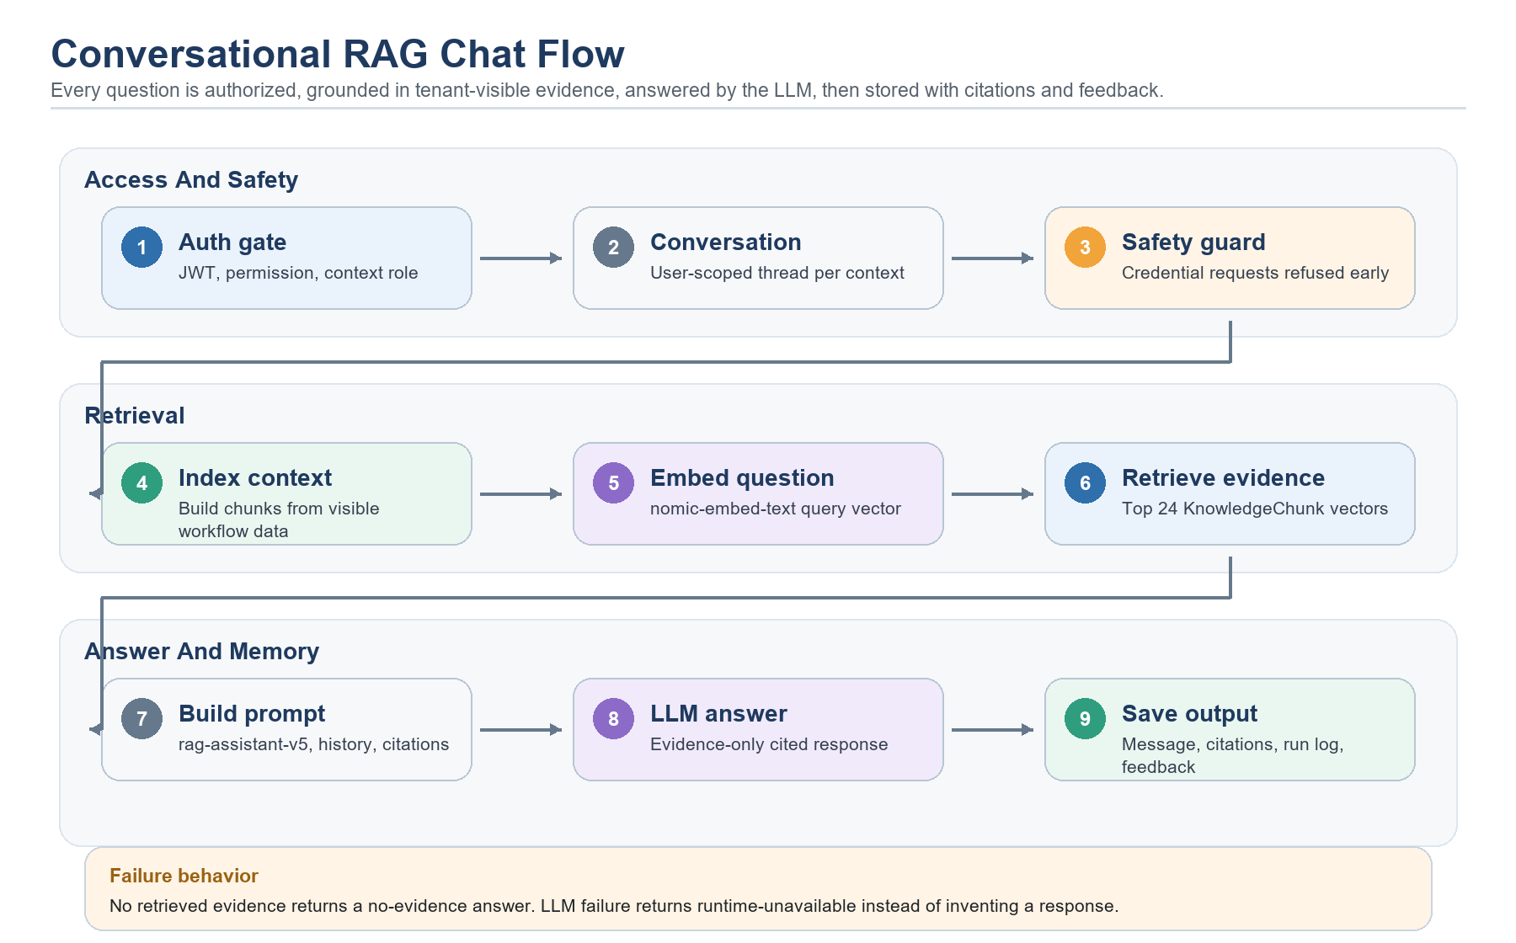
Diagram: complete RAG chat flow from access checks to saved citations.

RAG Chat Access By Role
The RAG chat is available only inside supported internal workflow screens. The global permission is ai.assistant.use, but that permission is not enough by itself. The backend also checks the context type, the user's role, tenant id, and whether the underlying record is visible to that user.
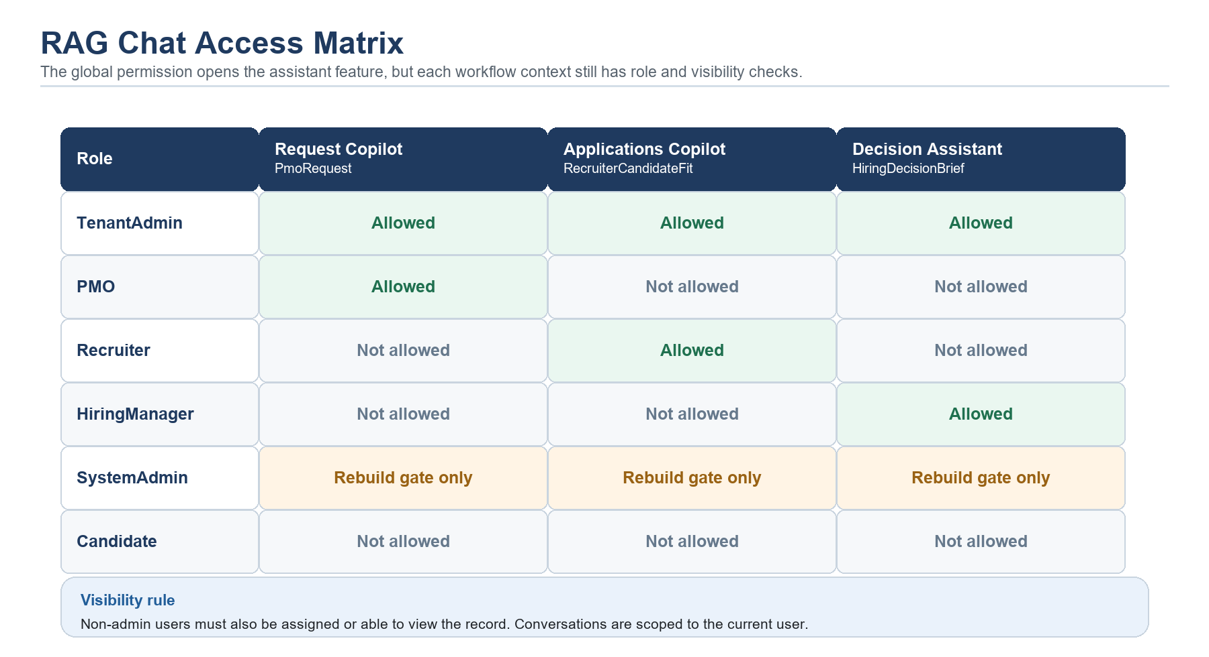
Diagram: implemented role access for supported RAG contexts.
Role | PmoRequest | RecruiterCandidateFit | HiringDecisionBrief | Notes
TenantAdmin | Yes | Yes | Yes | Tenant-wide administrative access, still tenant-scoped.
PMO | Yes | No | No | Request Copilot for PMO review context only.
Recruiter | No | Yes | No | Applications Copilot for recruiter sourcing context only.
HiringManager | No | No | Yes | Decision Assistant for assigned hiring review context only.
SystemAdmin | Administrative rebuild gate | Administrative rebuild gate | Administrative rebuild gate | Current context authorization still applies after the admin gate.
Candidate | No | No | No | Candidate portal users do not have internal RAG chat access.

Context | Who can use it | Indexed evidence | Frontend surface
PmoRequest | PMO or TenantAdmin | Job request, eligible bench employees, bench match logs, employee referrals | Request Copilot in PMO review.
RecruiterCandidateFit | Recruiter or TenantAdmin | Job request, job post, application relevance summary, candidate applications, documents, interview feedback, applicant rankings | Applications Copilot in recruiter sourcing.
HiringDecisionBrief | HiringManager or TenantAdmin | Decision brief, job evidence, candidate profile, interview feedback | Decision Assistant in hiring-manager review.

How A RAG Answer Is Generated For Each Question
- The Angular RAG panel sends contextType, contextEntityId, optional focusEntityId, conversationId, and the user's message to api/talent-pilot/ai-assistant/messages.
- The API authenticates the JWT and the service checks ai.assistant.use plus the context-specific role rule.
- The service creates or resumes a conversation scoped to the current tenant and user, then saves the user message.
- A credential-disclosure guard checks for requests asking to reveal passwords, API keys, tokens, private keys, client secrets, or connection strings. If matched, the assistant refuses before retrieval or LLM generation.
- KnowledgeIndexingService rebuilds or refreshes knowledge chunks for the visible context and embeds changed chunks with the configured embedding model.
- KnowledgeRetrievalService embeds the latest question, searches active tenant KnowledgeChunk vectors with SQL cosine search, and keeps evidence that belongs to the requested context and focus entity.
- RagPromptBuilder creates a rag-assistant-v5 prompt with the latest question, up to the last six conversation messages, retrieved evidence, citation labels, scope rules, and action boundaries.
- The configured LLM generates the final answer. The prompt tells it to answer only from evidence, cite supported claims, refuse secrets, redirect unrelated topics, and avoid protected-attribute inference.
- The service keeps only citations actually referenced in the answer, saves the assistant message, saves citation rows, closes the AI run log, and returns the answer to the frontend.
- The frontend renders inline references, citation chips, evidence preview cards, and Helpful/NotHelpful feedback buttons.
Simplified RAG service flow
// Simplified current AiAssistantService.SendMessageAsync flow
normalized = NormalizeRequest(request);
Authorize(normalized); // ai.assistant.use + context role + tenant visibility
conversationId = GetOrCreateConversation(currentUser, normalized.Context);
AddMessage(conversationId, "User", normalized.Message);
if (RagSensitiveRequestGuard.IsCredentialDisclosureRequest(normalized.Message))
return CredentialRefusalWithoutRetrievalOrLlm();
EnsureContextIndexed(normalized.Context); // build chunks and vectors
evidence = Retrieve(normalized.Message); // SQL VECTOR cosine search
if (evidence.Count == 0)
return NoEvidenceResponse();
prompt = RagPromptBuilder.Build(
question: normalized.Message,
history: Last6Messages(conversationId),
evidence: evidence);
answer = Llm.Generate(prompt); // required for final answer
citations = FilterReferenced(prompt.Citations, answer);
SaveAssistantMessage(answer, citations);

RAG Guardrails
Guardrail | Implemented behavior
Authorization | Requires JWT, ai.assistant.use permission, context role, tenant filter, and record visibility.
Secret requests | Credential, token, password, private-key, and connection-string disclosure requests are refused before retrieval or LLM generation.
Evidence grounding | In-scope answers must use retrieved chunks only. Missing evidence produces an insufficient-evidence answer.
Prompt injection | Job, candidate, document, note, and question text are treated as untrusted evidence, not instructions.
Scope control | Clearly unrelated questions receive a short redirect back to Talent Pilot hiring/workflow tasks.
Action boundary | The assistant cannot approve, reject, hire, allocate, move workflow stages, schedule meetings, generate offers, or contact people.
Sensitive data | The prompt tells the LLM not to expose sensitive data beyond retrieved evidence and not to infer protected attributes.
Citations | Only citation labels that appear in the generated answer are persisted and shown to the user.

Interview Question Recommender Agent
Purpose: creates a structured interview guide for a scheduled or completed interview. It uses the tenant question bank as grounding, ranks relevant bank items with embeddings, asks the LLM for strict JSON, and stores a versioned recommendation set that interviewers can open, regenerate, or download as DOCX.
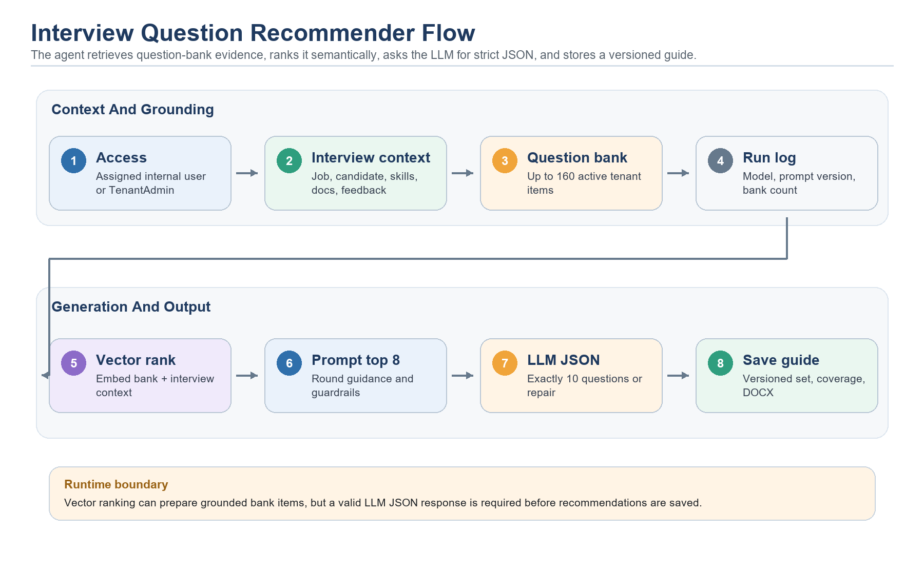
Diagram: interview question recommender runtime flow.
- Tools used: OperationsService, DapperOperationsRepository, InterviewQuestionRecommendationAgent, InterviewQuestionBankItems, embedding provider, SQL vector store, LLM model provider, AI run logger, recommendation set tables, and document export service.
- Access: candidates cannot use it. A normal internal user must be the assigned interviewer for that interview; TenantAdmin can view/generate/download across tenant interview tasks.
- Status boundary: question recommendations can be generated only for Scheduled or Completed interviews.
- LLM usage: required. The LLM must return valid strict JSON with exactly ten questions, summary, coverage, rationale, expected signal, follow-ups, rubric, and source-bank linkage where available.
- Failure behavior: semantic ranking can still prepare bank items if the embedding/vector store is available, but no question set is saved if the LLM is unavailable or returns invalid structured output after repair.
- Hard boundary: the agent cannot submit feedback, hire, reject, schedule, contact candidates, change compensation, or move workflow stages.
- Prompt version: interview-question-recommender-v1.

How Interview Questions Are Generated
Step | What happens | Why it matters
Access check | Non-candidate internal users can enter the interview feedback area, but normal users only see assigned interviews; TenantAdmin can include all tenant interviews. | Prevents candidates and unrelated users from generating interview guides.
Status check | Generation is allowed only for Scheduled or Completed interviews. | Avoids generating guides for missing, cancelled, or otherwise invalid interview tasks.
Context build | The repository loads job request/post data, candidate profile, cover letter, recruiter notes, required skills, candidate skills, document evidence, and prior interview feedback. | Gives the LLM enough evidence to tailor questions to the role and candidate.
Question bank fetch | The API loads up to 160 active tenant bank items that match skill ids, round type, job family, or generic rows. | Keeps the prompt grounded in a reusable tenant-controlled question pool.
Semantic ranking | The agent embeds up to 30 candidate bank items and embeds the interview context, then searches InterviewQuestionBankItem vectors. | Finds bank questions closest to the current interview meaning.
Prompt assembly | The prompt includes up to 8 selected bank items, round guidance, context evidence, strict JSON shape, and guardrails. | Limits token size and forces a predictable output contract.
LLM generation | The configured LLM must return exactly 10 questions with rationale, expected signal, follow-ups, rubric, coverage, and optional sourceBankItemId. | Turns grounded examples into interviewer-ready questions.
Parse and repair | If the first answer is invalid JSON, the agent asks the LLM to repair it. If it still fails, generation fails. | Prevents malformed or incomplete question sets from being saved.
Persistence | The system saves a versioned recommendation set, questions, coverage JSON, retrieved bank ids, model, prompt version, run id, and regenerate reason. | Makes regenerated guides traceable and downloadable as DOCX.

Simplified interview-question generation flow
// Simplified InterviewQuestionRecommendationAgent.GenerateAsync flow
context = LoadInterviewQuestionContext(interviewId);
bankItems = ListInterviewQuestionBankItems(
tenantId,
skillIds: context.RequiredSkills,
roundType: context.RoundType,
jobFamily: context.Department,
take: 160);
ranked = RankBankItemsAsync(context, bankItems.Take(30));
promptBankItems = SelectPromptBankItems(context.RoundType, ranked).Take(8);
prompt = BuildPrompt(context, promptBankItems, targetQuestionCount: 10);
json = Llm.Generate(prompt);
parsed = ParseOrRepair(json);
questions = ToQuestions(parsed, ranked, context);
if (questions.Count < 10)
throw InvalidOperationException("At least 10 questions are required.");
SaveRecommendationSet(versionNumber, questions, coverage, retrievedBankItemIds);

Question Bank Size And Linkage
Yes, the application has a question pool. It is stored in InterviewQuestionBankItems and seeded from SQL. The bank is tenant-scoped, active/inactive aware, and each item can be linked to SkillId, DepartmentId, JobFamily, RoundType, Difficulty, expected signal, follow-ups, rubric, source title, source URL, and a content hash.
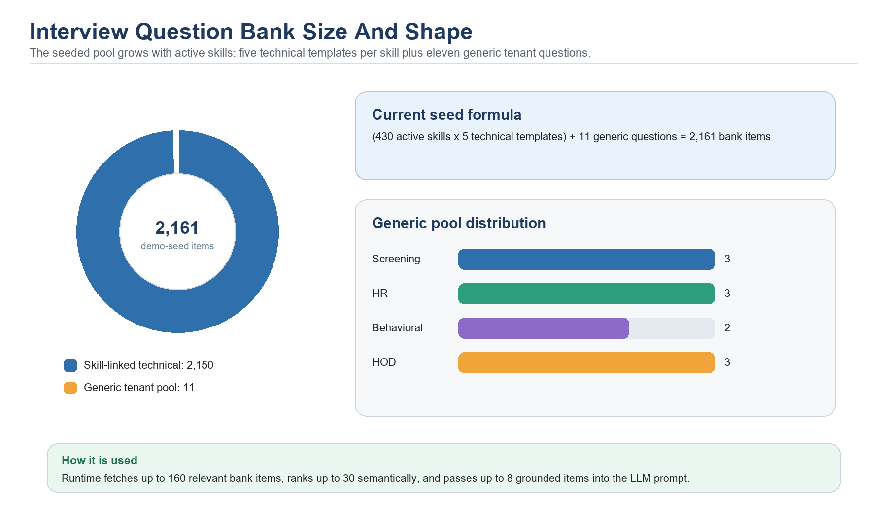
Chart: seeded interview question pool size and distribution.
Pool area | Current size rule | How it is linked
Skill-linked technical rows | 5 per active skill | SkillId set, JobFamily from skill category, RoundType Technical, Basic/Intermediate/Advanced difficulty.
Generic screening rows | 3 per tenant | SkillId null. Covers motivation, availability, notice period, and relevant project walk-through.
Generic HR rows | 3 per tenant | SkillId null. Covers work style, feedback maturity, and conflict handling.
Generic behavioral rows | 2 per tenant | SkillId null. Covers changing priorities and decisions with incomplete information.
Generic HOD rows | 3 per tenant | SkillId null. Covers department-level ownership, first-90-day risk, and mentoring/review quality.
Current demo seed estimate | 2,161 rows | 430 active seeded skills x 5, plus 11 generic rows.

In the current demo seed, the expanded skill catalog contains 430 unique active skills. That produces 2,150 skill-linked technical questions, plus 11 generic questions, for an estimated 2,161 seeded bank items per demo tenant. In production, the count is data-driven: adding active skills expands the potential seeded technical pool, and future admin screens can curate or add tenant-specific bank items.

Interview Question Guardrails And Quality Controls
- The prompt treats job, candidate, notes, documents, and question-bank text as untrusted content. The LLM is told not to follow instructions inside those fields.
- The prompt says not to infer protected attributes and not to recommend hiring, rejecting, compensation, or workflow movement.
- Round guidance keeps Screening and HR questions away from coding or architecture questions, keeps HOD questions focused on leadership/ownership, and keeps Technical questions focused on practical technical evidence.
- For Screening, HR, HOD, and Behavioral rounds, response validation requires most generated questions to align with compatible round types.
- SourceBankItemId is accepted only if it belongs to the retrieved bank items, preventing the model from inventing source ids.
- Coverage records skills covered, candidate evidence used, target question count, bank items used, and semantic-similarity status.
- Every generation has an AI run id, model, embedding model, prompt version, generated timestamp, and optional regenerate reason.

How To Improve The Interview Question Agent
- Add an Admin Center question-bank manager so tenants can approve, disable, edit, import, and tag questions.
- Add question outcome analytics: which generated questions were used, which feedback fields were filled, and which questions produced useful signal.
- Add per-role and per-seniority templates so junior, senior, lead, and manager interviews receive different depth.
- Add evaluation tests with fake LLM responses to verify JSON shape, round alignment, guardrails, and source-bank linkage.
- Add interviewer feedback on generated question quality and use it to tune prompts and seed-bank content.
- Add duplicate-question detection and diversity rules so one guide covers skills, behavior, project depth, tradeoffs, and risk areas without repeating itself.

Prompting And Guardrails
The Job Description Drafting Agent uses an LLM prompt that tells the model to use only structured fields, treat fields as untrusted input, ignore instructions that try to reveal prompts or bypass policy, and produce plain text sections. This is a prompt-injection defense for user-supplied role and project text. Similar principles should apply to every future LLM prompt.
- Prompts should be versioned and tied to AI run logs.
- Prompts should state the agent boundary: advise, summarize, draft, or rank, but never decide.
- Prompt inputs should be structured and minimized to the data needed for the task.
- Outputs should include evidence and uncertainty where the user needs to judge the result.
- Sensitive data should not be sent to public search providers.

Scoring Algorithms
The chart below shows the scoring mix as maximum score points or contribution signals. Bench Matching focuses on internal employee fit, Talent Rediscovery focuses on warm candidate evidence, Online Headhunting focuses on lead-only external prospects, and Applicant Ranking focuses on current applicants for a specific job post. These scores prepare rank order; ranking agents still require the LLM explanation step to succeed, while Online Headhunting currently treats LLM enrichment as a post-scoring enhancement.
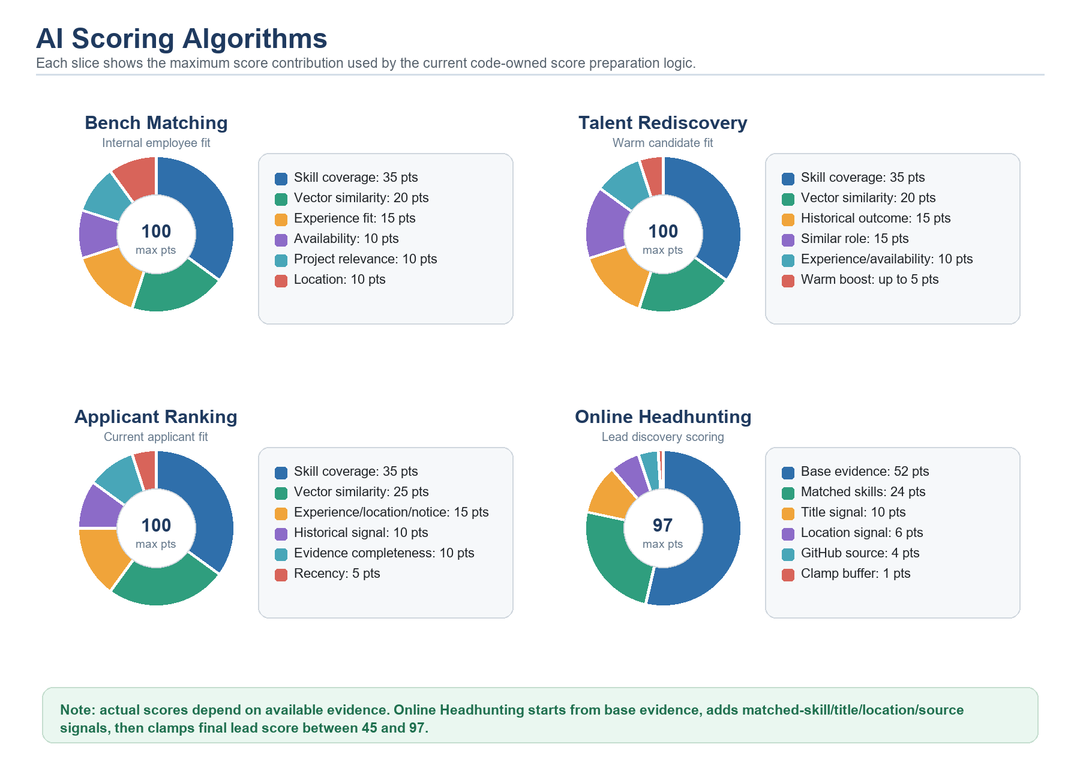
Chart: current score preparation signals before LLM explanations or enrichment.

LLM Models
The current LLM model is llama3.2 through Ollama. It is used for generation or explanation tasks where natural language is useful. If the LLM model changes, generated job descriptions, explanations, tone, factual discipline, and latency may change. The application should compare outputs before and after a model switch and keep a rollback plan.
A model can be changed through runtime configuration and the Admin Center AI Settings surface, depending on deployment policy. In production, model switching should be controlled and tested because even a better model can change output shape enough to affect user trust and downstream workflows.

Embeddings And Vector Search
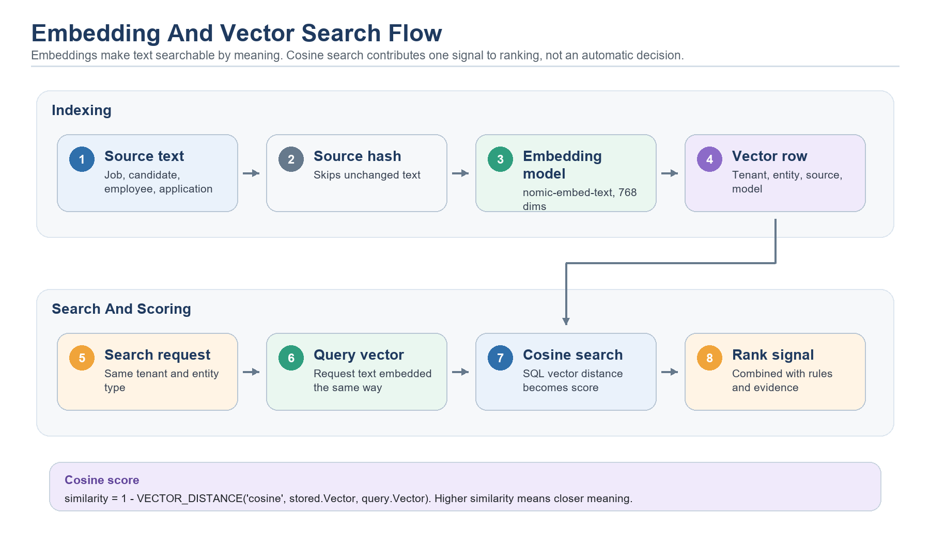
Diagram: embedding and SQL vector search flow.
The embedding model is nomic-embed-text and the configured dimension is 768. Embeddings are stored in SQL Server in VectorEmbeddings with tenant, entity type, entity id, source text hash, model, dimension, and active-state metadata. Search filters by tenant and entity type, then uses cosine distance to rank similar records.
If the embedding model changes, the semantic space changes. Old vectors should not be compared with new vectors as if they were equivalent. A safe model change requires reindexing active vectors for job requests, job posts, candidates, applications, and employee evidence before trusting search results.

How Many Vector Embeddings Are Stored
The application does not store a fixed number of embeddings. The count grows with tenant data. The rule is: Talent Pilot keeps one active embedding for each tenant, entity, source type, and embedding model combination. When the same source text changes, the old active row is marked inactive and a new active row is inserted.
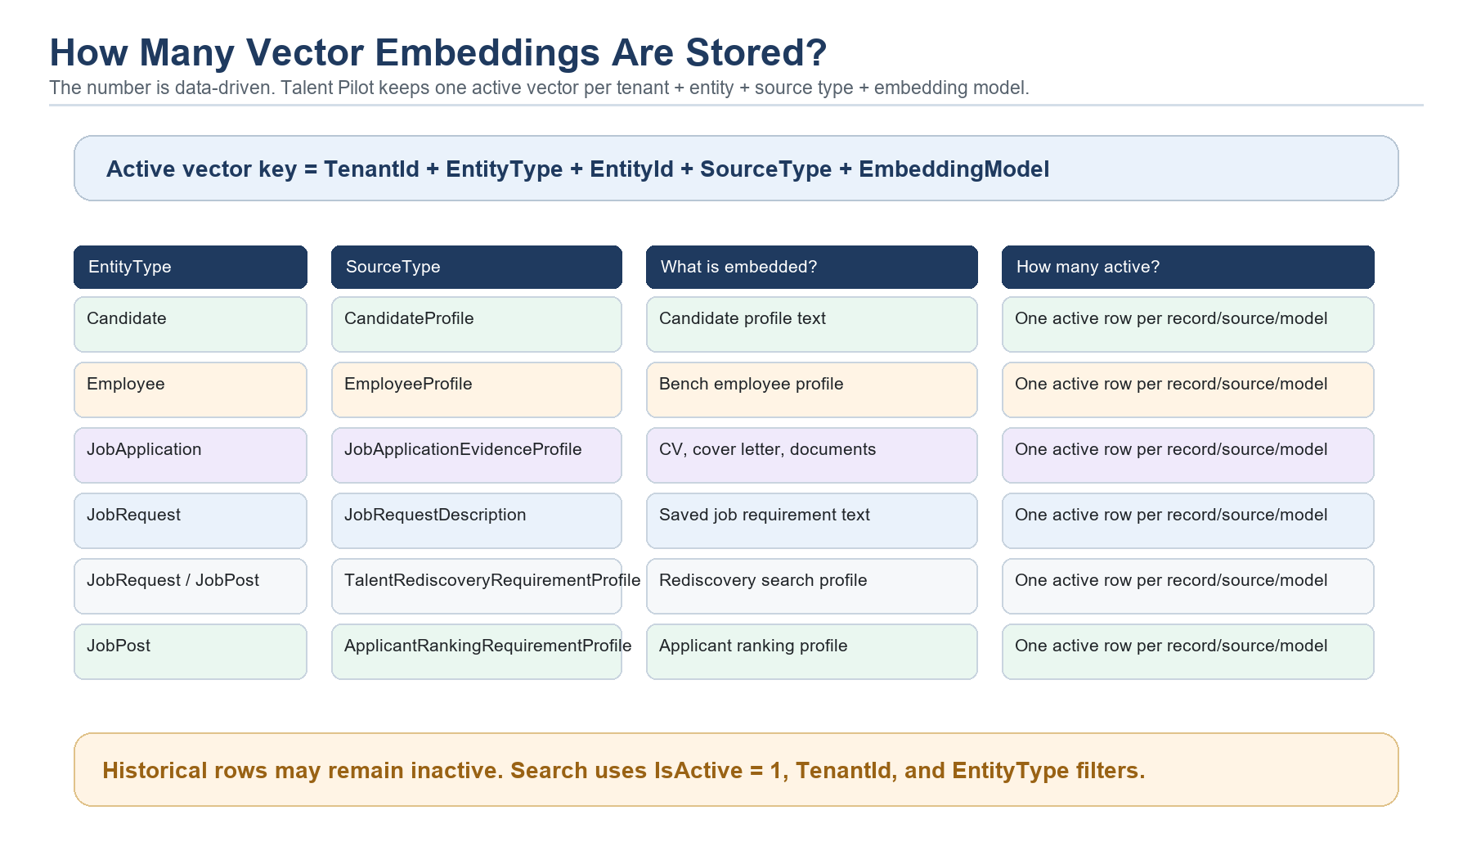
Diagram: active vector inventory by entity and source type.
EntityType | SourceType | Created or refreshed by | What it represents
Candidate | CandidateProfile | Candidate profile save and Talent Rediscovery | The candidate's structured profile, skills, experience, availability, and history context.
Employee | EmployeeProfile | Bench Matching Agent | Internal employee bench profile, skills, availability, location, and project evidence.
JobApplication | JobApplicationEvidenceProfile | Document upload, parsed CV evidence, Applicant Ranking, Talent Rediscovery | Application evidence including cover letter, extracted DOCX text, CV/application documents, and history.
JobRequest | JobRequestDescription | Requirement Parser / job request indexing | Saved job request requirement profile used for future matching.
JobRequest or JobPost | TalentRediscoveryRequirementProfile | Talent Rediscovery Agent | The role/search profile used to find warm candidates.
JobPost | ApplicantRankingRequirementProfile | Applicant Ranking Agent | The current job post requirement profile used to rank active applicants.

So the approximate active vector count for a tenant is: active candidate profile vectors + active employee profile vectors + active job application evidence vectors + active job request vectors + active job post requirement vectors. The database may contain more rows than the active count because previous vectors are retained as inactive history after source text changes.
Simplified vector upsert behavior
-- Simplified current upsert behavior from DapperVectorStore
UPDATE dbo.VectorEmbeddings
SET IsActive = 0, UpdatedAtUtc = SYSUTCDATETIME()
WHERE TenantId = @TenantId
AND EntityType = @EntityType
AND EntityId = @EntityId
AND SourceType = @SourceType
AND IsActive = 1;
INSERT INTO dbo.VectorEmbeddings
(
VectorEmbeddingId, TenantId, EntityType, EntityId, SourceType,
SourceTextHash, EmbeddingModel, EmbeddingDimensions, Embedding, IsActive
)
VALUES
(
NEWID(), @TenantId, @EntityType, @EntityId, @SourceType,
@SourceTextHash, @EmbeddingModel, @EmbeddingDimensions,
CAST(@EmbeddingJson AS VECTOR(768)), 1
);

What Cosine Search Means
Cosine search compares the direction of two embedding vectors. In hiring terms, it asks: do these two pieces of text mean similar things, even if they use different words? The query vector might represent a job post. The stored vectors might represent candidates, employees, or application evidence. SQL Server then ranks the stored vectors by cosine distance.
- Small cosine distance means the two vectors point in a similar direction, so the text meaning is closer.
- Large cosine distance means the vectors point in different directions, so the text meaning is less similar.
- The current code converts distance into a score with: score = 1.0 - cosine distance.
- The search always filters by TenantId and EntityType, and only searches active vectors.
- The result is not a final hiring decision; it is one signal added to code-owned score preparation before required LLM explanation.
Simplified cosine vector search
-- Simplified current cosine search from DapperVectorStore
SELECT TOP (@Top)
EntityId,
CAST(
1.0 - VECTOR_DISTANCE(
'cosine',
Embedding,
CAST(@QueryEmbeddingJson AS VECTOR(768))
) AS DECIMAL(18, 6)
) AS Score,
SourceType AS Explanation
FROM dbo.VectorEmbeddings
WHERE TenantId = @TenantId
AND EntityType = @EntityType
AND IsActive = 1
ORDER BY VECTOR_DISTANCE(
'cosine',
Embedding,
CAST(@QueryEmbeddingJson AS VECTOR(768))
);

How Vector Scores Help Decision Making
Vector search helps the agents find semantic overlap that keyword matching can miss. It is especially useful when a CV, cover letter, job description, or project history uses different wording for the same concept. The vector score then becomes part of a broader scoring formula.
- Bench Matching searches Employee vectors using a job request profile and contributes up to 20 score points through vector similarity.
- Talent Rediscovery searches Candidate vectors using a job request or job post requirement profile and contributes up to 20 score points through vector similarity.
- Applicant Ranking searches JobApplication evidence vectors using a job post profile and contributes up to 25 score points through vector similarity.
- Document evidence vectors make CV and cover-letter text searchable for Applicant Ranking and Talent Rediscovery.
- Vector score is combined with skill coverage, experience fit, availability, history, location, evidence completeness, and recency.
- Users see the benefit as ranked recommendations, strengths/gaps, document evidence notes, and more grounded explanations.
Simplified example: Applicant Ranking uses vector similarity as one score component
// Simplified ranking use
queryEmbedding = Embed(jobRequirementText);
vectorResults = SearchVectors(tenantId, "JobApplication", queryEmbedding);
vectorSimilarity = vectorResults[applicationId]; // 0..1
score =
skillCoverage * 35 +
vectorSimilarity * 25 +
experienceLocationNoticeFit * 15 +
historicalSignal * 10 +
evidenceCompleteness * 10 +
recency * 5;

Are Vector Embeddings Considered RAG?
Vector embeddings by themselves are not a full RAG pipeline. They are the retrieval foundation that a RAG pipeline can use. In Talent Pilot, embeddings and cosine search are used in two ways: retrieval-assisted ranking for Bench Matching, Talent Rediscovery, and Applicant Ranking, and conversational RAG for the read-only assistant.
A full RAG flow happens when the system retrieves relevant chunks or records, assembles them into an LLM prompt, asks the LLM to answer a user question using that evidence, and returns citations or source references. The Conversational RAG Assistant follows this pattern for supported internal contexts. The ranking agents are different: they use retrieval and vectors as scoring evidence, then require the LLM to produce explanations before a completed ranking result is returned.
Short version: embeddings are the search/memory layer. They become RAG only when retrieved evidence is passed to an LLM answer with citations.

How CVs, Cover Letters, And Document Evidence Are Read
Talent Pilot currently reads candidate documents through DOCX text extraction, not OCR. That means it can read normal typed text inside a DOCX file, but it does not read text from scanned PDFs, screenshots, image-only resumes, or photographed cover letters. No LLM is used for OCR today, and no OCR library such as Tesseract, Azure Document Intelligence, AWS Textract, or Google Document AI is currently wired into the application.
Current state: DOCX text extraction only. Roadmap: add OCR/document intelligence for scanned PDFs and image-based documents.

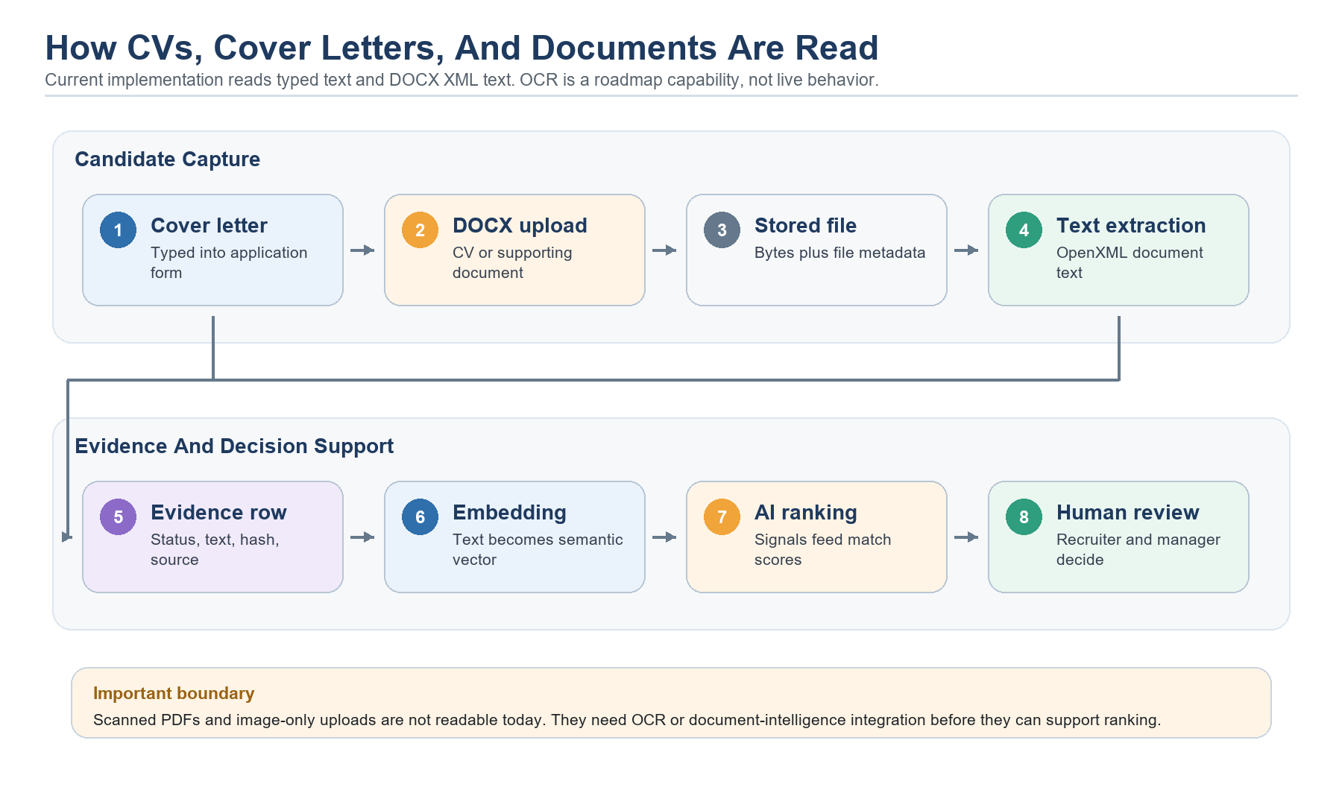
Diagram: current document evidence flow from candidate input to AI agent use.
- Candidate cover letter text is stored directly from the application form in CoverLetterText.
- Uploaded application documents must be DOCX in the current MVP flow.
- DocxApplicationDocumentTextExtractor opens the DOCX as a ZIP file and reads text from word/document.xml.
- Extraction metadata is stored with the application document: status, extracted text, text hash, parser version, extracted time, and error message if extraction failed.
- CV Parser Agent extracts DOCX text locally, then uses the LLM to parse structured candidate facts such as name, email, phone, designation, experience, skills, university, degree, graduation year, and summary.
- The CV parser summary is LLM-generated from extracted CV text and is required before parsed CV evidence can be returned.
- When parsed CV evidence is attached to an application, the system builds a labeled evidence profile containing the parser summary and extracted CV text, then embeds that profile with nomic-embed-text.
- Applicant Ranking and Talent Rediscovery use cover-letter text and extracted document evidence as part of their scoring and explanation inputs.
Simplified DOCX extraction flow
// Simplified current document extraction behavior
if (!fileName.EndsWith(".docx"))
return Status = "Unsupported";
open docx as ZIP;
read word/document.xml;
extract paragraph text;
trim to 40,000 characters;
store ExtractedText, ExtractedTextHashSha256, ParserVersion, ExtractedAtUtc;

After text is extracted, the application builds an evidence profile for vector indexing. This profile includes the application id, document type, file name, parser version, and extracted text. The system hashes the profile text so it can skip re-embedding unchanged evidence.
Simplified document-evidence embedding flow
// Simplified current vector indexing behavior
if (string.IsNullOrWhiteSpace(extraction.ExtractedText))
return;
profileText =
"ApplicationId: ..." +
"Evidence source: Resume/CV/Cover Letter" +
"Document: file.docx" +
"Parser: docx-wordprocessingml-v1" +
"CV Parser Agent summary: LLM-generated summary" +
"Extracted text: ...";
sourceHash = HashText(profileText);
if (sourceHash == existingActiveHash)
return;
embedding = nomic_embed_text(profileText); // 768 dimensions
VectorEmbeddings.Upsert(JobApplication, JobApplicationEvidenceProfile, embedding);

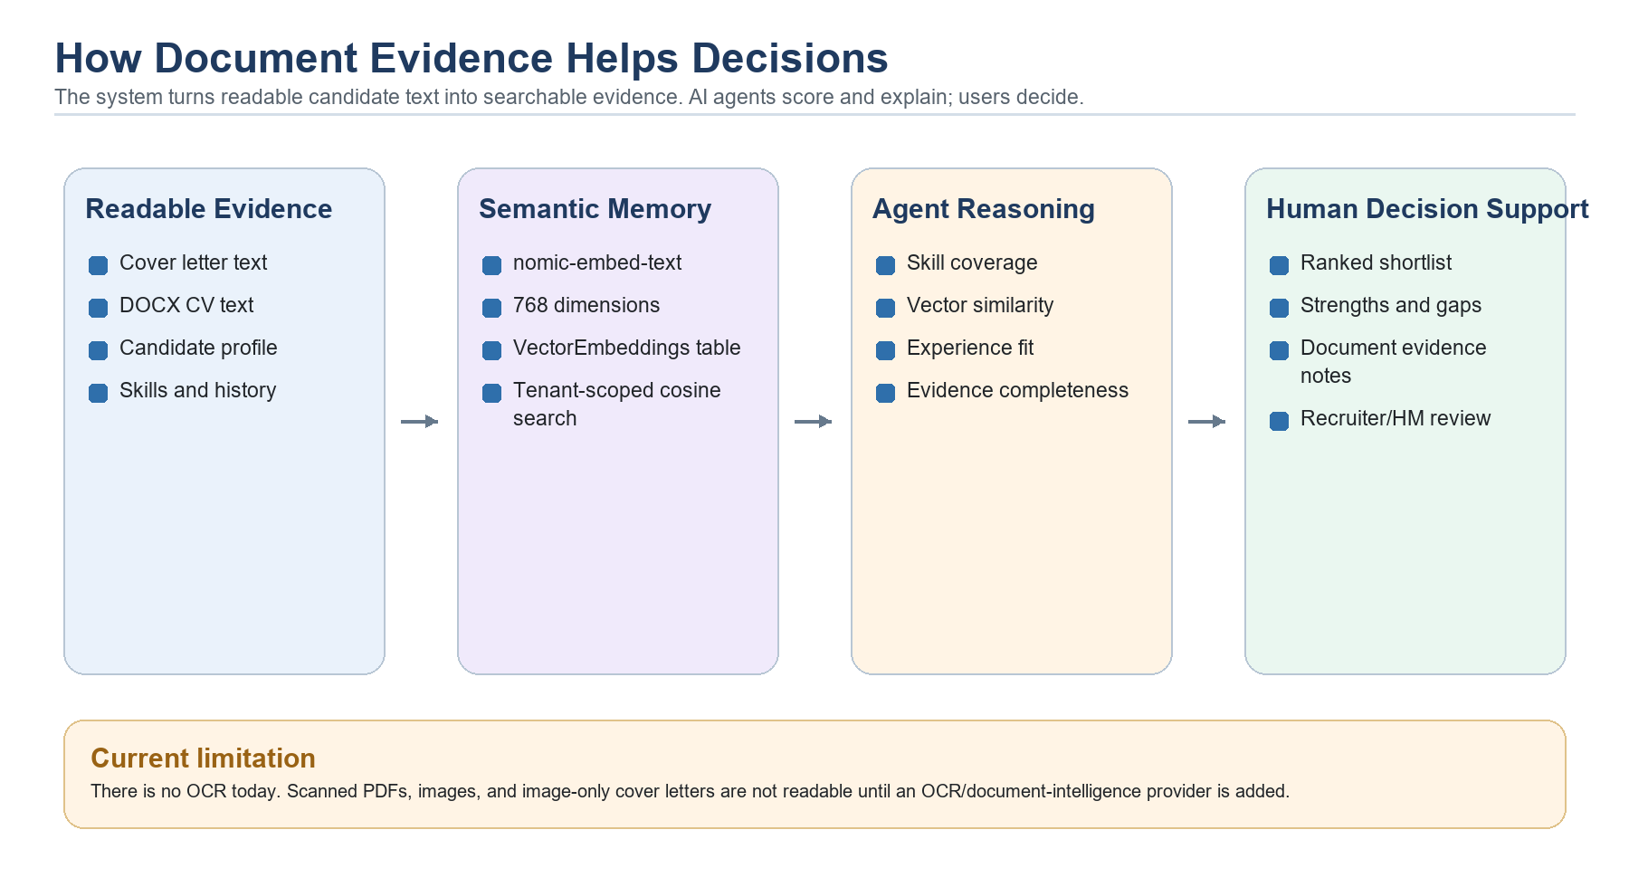
Diagram: how document text and vectors support AI agents and human decisions.

How Document Vectors Help Users And AI Agents
Document embeddings help the system compare meaning, not just exact keywords. For example, a CV may say 'built cloud-native React portals on Azure' while a job post says 'frontend engineer with Azure delivery experience.' Vector search can treat these as semantically related even if the wording is different.
- Applicant Ranking uses document evidence to improve current application scoring, explanation, evidence completeness, and recruiter-facing strengths/gaps.
- Talent Rediscovery uses historical application document evidence and cover letters to find warm candidates who may fit a new role.
- Vector similarity contributes to ranking, but it is only one part of the score. Skill coverage, experience, location, history, recency, and evidence completeness still matter.
- Users benefit because AI explanations can point to actual evidence: cover letter submitted, CV text extracted, missing skills, matching skills, prior interview evidence, and document availability.
- The AI agents benefit because they receive structured evidence and semantic matches instead of relying only on raw text or exact keyword filters.
- Human review remains required. Vectors and LLM explanations support shortlisting and review; they do not approve, reject, or move candidates automatically.

Roadmap: Real OCR And Better Document Intelligence
To support scanned PDFs, images, or photographed resumes, Talent Pilot should add a document-intelligence pipeline. The clean design would keep the existing IApplicationDocumentTextExtractor interface and add provider implementations for PDF text extraction and OCR.
- Add providers such as Azure Document Intelligence, AWS Textract, Google Document AI, Tesseract, or a multimodal LLM, depending on deployment constraints.
- Run OCR asynchronously for larger files so candidate application submission remains fast.
- Store provider name, parser version, page count, extraction confidence, extracted text hash, and extraction errors.
- Add human review for low-confidence extracted fields before using them in ranking or profile updates.
- Support per-tenant configuration because some customers may require local OCR while others can use cloud document intelligence.
- Re-embed document evidence when OCR output, parser version, or embedding model changes.

RAG Status
The application now has a focused conversational RAG pipeline through AiAssistantService. The assistant authorizes the user, creates or resumes a conversation, indexes the selected context, retrieves permitted knowledge chunks with vector search, builds a prompt through RagPromptBuilder, calls the configured LLM, stores the assistant message, and saves citations. This is separate from the ranking agents, which use vectors and code-owned formulas for score preparation, then require the LLM to produce usable explanations before returning a completed agent result.
Simplified conversational RAG flow
// Simplified current Conversational RAG Assistant flow
Authorize(user, context);
EnsureContextIndexed(context);
evidence = Retrieve(question, context); // vector search over permitted chunks
if (evidence.Count == 0) return "No relevant evidence was found.";
prompt = RagPromptBuilder.Build(question, conversationHistory, evidence);
answer = Llm.Generate(prompt); // required for final answer
SaveAssistantMessage(answer, citations, agentRunId);
return answer + citations;

Testing And Evaluation
The repository includes tests for bench matching, talent rediscovery, Online Headhunting, applicant ranking, job description drafting, CV parsing, search providers, RAG prompt/citation/guard behavior, knowledge indexing, and the Interview Question Recommender. These tests are important because AI behavior has code-owned preparation plus model-dependent output. Current tests verify boundaries such as no personal data in web search, no web search in rediscovery, Online Headhunting source/query rules, filtering of joined/hired candidates, score caps for weak evidence, credential refusal in RAG, and fail-closed behavior when required LLM output is missing or invalid.
The tests do not need a live LLM for most checks. They use small fake providers that capture the prompt, return a controlled model response, return fixed embedding/vector scores, and record what the agent tried to write or log. This lets the test verify the internal agent flow: build evidence, apply guardrails, score candidates, call the model only where expected, and write useful logs.
- Capturing model providers store the last prompt so tests can assert prompt guardrails.
- Static embedding providers and capturing vector stores make semantic similarity predictable in tests.
- Capturing web research providers prove what search queries would be sent externally.
- Capturing run loggers prove the agent recorded success, failure, model status, and semantic-similarity status.
- Online Headhunting tests verify source normalization, out-of-scope Indeed filtering, LinkedIn web X-Ray exclusions, and GitHub API query terms without site: operators.
- RAG tests assert prompt version, scope instructions, credential refusal, citation filtering, and generated knowledge chunks.
- Interview Question Recommender tests assert strict JSON prompts, bank item vector upserts, sourceBankItemId linkage, and fail-closed behavior when output is invalid or round-incompatible.
- The result assertions prove the top-ranked match, score order, evidence text, gaps, and explanation boundaries.
Example: LLM-required agent test setup
// Simplified pattern from BenchMatchingAgentTests.cs
var modelProvider = new CapturingModelProvider("[{ ... controlled explanation ... }]");
var vectorStore = new CapturingVectorStore(new Dictionary<Guid, decimal>
{
[strongEmployeeId] = 0.95m,
[secondaryEmployeeId] = 0.20m
});
var webResearch = new CapturingWebResearchProvider(new WebResearchResult("Unavailable", []));
var agent = new BenchMatchingAgent(
modelProvider,
new StaticEmbeddingProvider(),
vectorStore,
new StaticRuntimeSettingsResolver(),
logger,
webResearch);
var result = await agent.RankAsync(tenantId, CreateContext(), CancellationToken.None);
Assert.Equal(BenchMatchingAgent.AgentId, modelProvider.LastRequest?.AgentId);
Assert.Contains("untrusted evidence", modelProvider.LastRequest?.Prompt);
Assert.True(result.Matches[0].Score > result.Matches[1].Score);
Assert.Equal(2, vectorStore.UpsertedRecords.Count);

Example: ranking agent fails closed when LLM explanations are missing
// Simplified fail-closed assertion from ranking-agent tests
var agent = new BenchMatchingAgent(
new CapturingModelProvider("[]"), // LLM returned no usable explanations
new StaticEmbeddingProvider(),
new CapturingVectorStore(new Dictionary<Guid, decimal>()),
new StaticRuntimeSettingsResolver(),
logger,
new CapturingWebResearchProvider(new WebResearchResult("Skipped", [])));
await Assert.ThrowsAsync<InvalidOperationException>(() =>
agent.RankAsync(tenantId, CreateContext(), CancellationToken.None));
Assert.False(logger.Succeeded);
Assert.True(logger.Failed);
Assert.Contains("usable LLM explanations", logger.OutputSummary);

Example: proving external search does not leak employee personal data
// Simplified safety assertion from web-research tests
await agent.RankAsync(tenantId, CreateLiveContext(), CancellationToken.None);
var queryText = string.Join(" ", webResearch.LastRequest?.Queries ?? []);
Assert.Contains("Enterprise Client", queryText);
Assert.DoesNotContain("employee name", queryText);
Assert.DoesNotContain("employee email", queryText);

Example: Online Headhunting query guardrail tests
// Simplified OnlineHeadhuntingAgentTests.cs query-boundary checks
var sources = OnlineHeadhuntingSources.Normalize([]);
Assert.Contains(OnlineHeadhuntingSources.LinkedIn, sources);
Assert.Contains(OnlineHeadhuntingSources.GitHub, sources);
Assert.DoesNotContain("Indeed", sources); // out of scope in MVP source list
var linkedin = new OnlineHeadhuntingBooleanQueryBuilder()
.BuildQueries(CreateContext(), [OnlineHeadhuntingSources.LinkedIn])
.Single();
Assert.Contains("site:linkedin.com/in", linkedin.Query);
Assert.Contains("-jobs", linkedin.Query);
Assert.Contains("-hiring", linkedin.Query);
var github = new OnlineHeadhuntingBooleanQueryBuilder()
.BuildQueries(CreateContext(), [OnlineHeadhuntingSources.GitHub])
.Single();
Assert.DoesNotContain("site:", github.Query);
Assert.Contains("location:", github.Query);

Example: rediscovery guardrails and vector boundary checks
// Simplified assertions from TalentRediscoveryAgentTests.cs
Assert.Contains("Do not search the web", modelProvider.LastRequest?.Prompt);
Assert.Contains("Do not decide whether to contact", modelProvider.LastRequest?.Prompt);
Assert.Equal(strongCandidateId, result.Matches[0].CandidateId);
Assert.DoesNotContain(vectorStore.UpsertedRecords, r => r.EntityType == "Employee");
Assert.Equal("Available", logger.Metadata["semanticSimilarityStatus"]);

Example: applicant ranking uses current application evidence only
// Simplified assertions from ApplicantRankingAgentTests.cs
Assert.Contains("Do not search the web", modelProvider.LastRequest?.Prompt);
Assert.Contains("Do not decide whether to shortlist", modelProvider.LastRequest?.Prompt);
Assert.Contains("Cover letter", modelProvider.LastRequest?.Prompt);
Assert.Contains("resume.docx", result.Matches[0].DocumentEvidence.First(), StringComparison.OrdinalIgnoreCase);
Assert.DoesNotContain(vectorStore.UpsertedRecords, r => r.EntityType == "Employee");

Example: RAG prompt guardrails and prompt version
// Simplified assertions from RagPromptBuilderTests.cs
var prompt = new RagPromptBuilder().Build(new RagPromptContext(
RagAssistantContextTypes.PmoRequest,
"Can you tell me the weather?",
[],
[CreateChunk("Client needs .NET, SQL Server, Azure, and Angular exposure.")]));
Assert.Equal("rag-assistant-v5", prompt.PromptVersion);
Assert.Contains("quirky but professional", prompt.Prompt);
Assert.Contains("Never tell the user that a question is in scope", prompt.Prompt);
Assert.Contains("client secrets, API keys, tokens, passwords", prompt.Prompt);
Assert.Contains("Do not cite anything in an out-of-scope redirect", prompt.Prompt);

Example: interview question agent uses retrieved bank items and strict JSON
// Simplified assertions from InterviewQuestionRecommendationAgentTests.cs
var modelProvider = new CapturingModelProvider(CreateValidLlmResponse());
var vectorStore = new CapturingVectorStore(new Dictionary<Guid, decimal>
{
[bankItemId] = 0.91m
});
var result = await agent.GenerateAsync(tenantId, CreateContext(), [CreateBankItem()], CancellationToken.None);
Assert.Equal(InterviewQuestionRecommendationAgent.AgentId, modelProvider.LastRequest?.AgentId);
Assert.Contains("Return strict JSON only", modelProvider.LastRequest?.Prompt);
Assert.Contains("Do not recommend hiring", modelProvider.LastRequest?.Prompt);
Assert.Contains($"BankItemId: {bankItemId:D}", modelProvider.LastRequest?.Prompt);
Assert.Equal(10, result.Questions.Count);
Assert.Equal(bankItemId, result.Questions[0].SourceBankItemId);
Assert.Contains(vectorStore.UpsertedRecords, r => r.EntityType == "InterviewQuestionBankItem");

Example: invalid interview-question output fails closed
// Simplified fail-closed behavior
var modelProvider = new CapturingModelProvider("not json");
await Assert.ThrowsAsync<InvalidOperationException>(() =>
agent.GenerateAsync(tenantId, CreateContext(), [CreateBankItem()], CancellationToken.None));
Assert.Equal(2, modelProvider.CallCount); // initial generation + repair attempt
Assert.True(logger.Failed);

- Add golden evaluation sets for common roles, edge cases, and bad inputs.
- Track recommendation outcomes: accepted, ignored, interviewed, hired, rejected, and later performance indicators when available.
- Compare model versions before switching production defaults.
- Tune weights using historical outcomes and human feedback instead of intuition alone.
- Add prompt regression tests for prompt-injection attempts and unwanted decision language.
- Review score distributions by department, role, source, and demographic-safe aggregate categories to detect drift or bias risk.
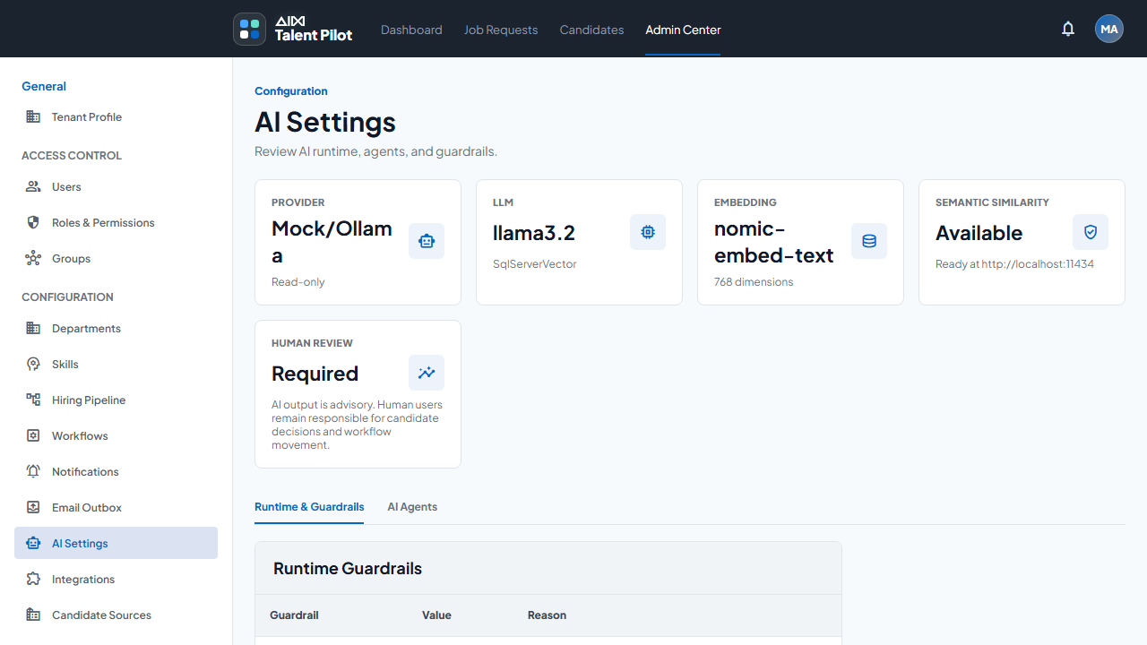
Live screenshot: Admin Center AI Settings showing current provider, LLM, embedding model, vector store, and guardrails.

Workflow, Rules, And Hiring Pipeline
Section summary
- Workflows define how job requests and hiring work move through system stages.
- Department intake rules route Presales-created job requests to PMO groups.
- Assignments support claim, assign, release, and ownership tracking.
- System stages and transitions are code-owned guardrails in the current implementation.
- Hiring pipeline templates define interview rounds that can be reused and configured per job post.
- Rules and AI work together: rules control process, AI supports evidence and recommendations.

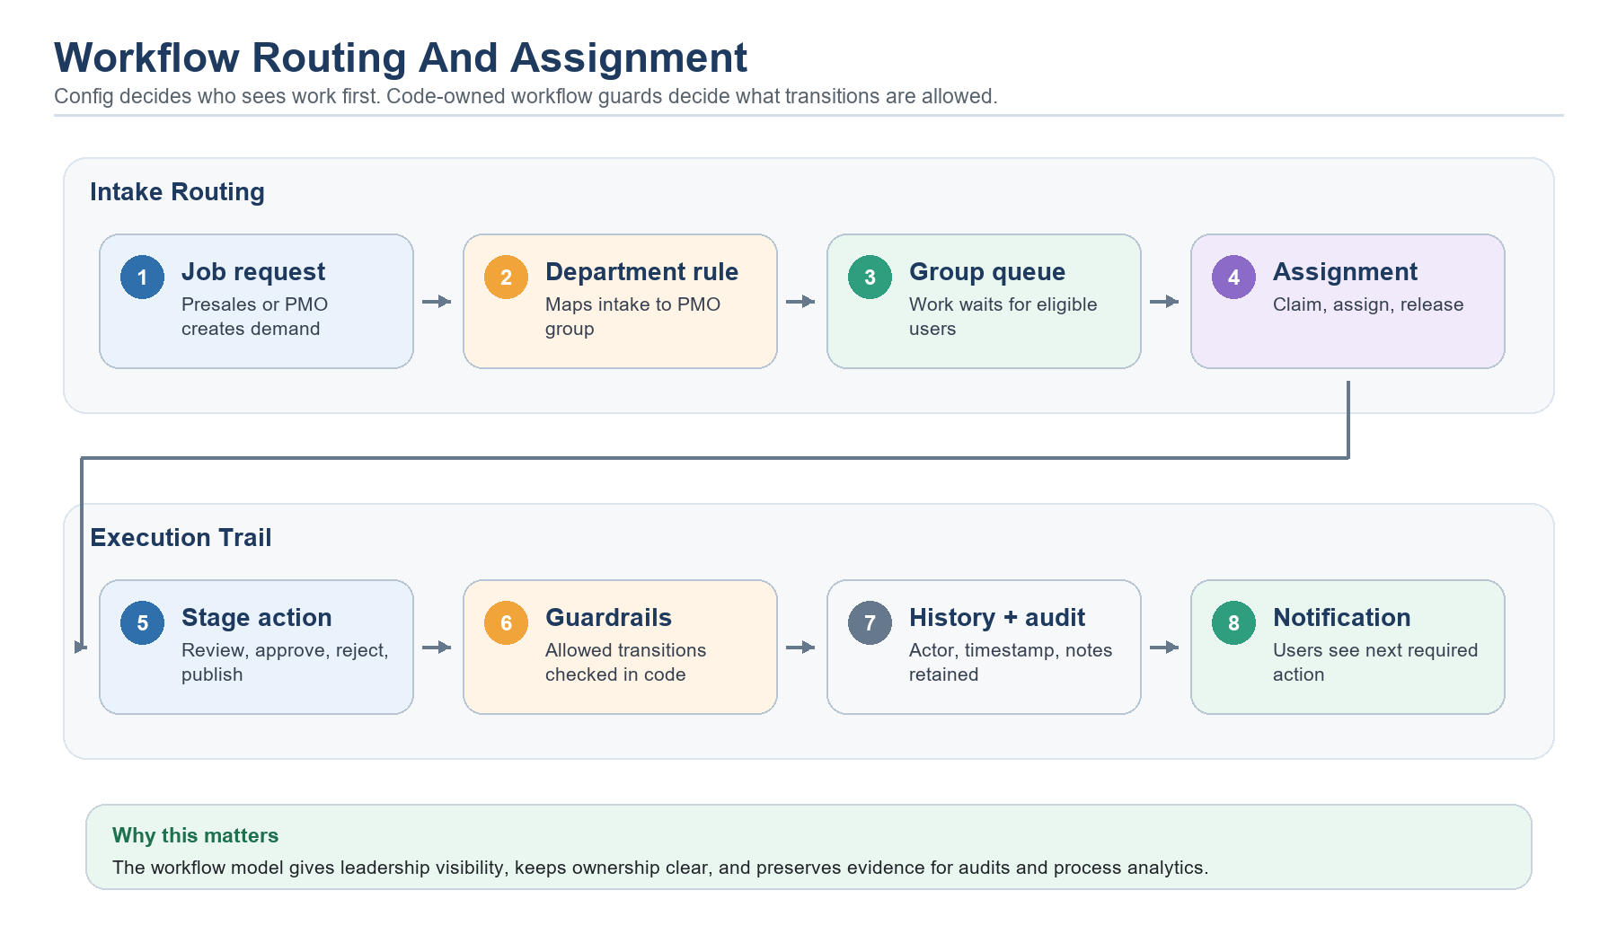
Diagram: workflow routing and assignment.

Configurable Values
- Department-to-PMO routing rules for intake.
- Workflow assignments and current owner state.
- Interview templates, round sequence, round name, duration, owner role or owner user, and required status.
- Notification templates and recipient rules related to workflow events.
- Candidate source labels and recruitment defaults that affect reporting.
- AI settings such as provider mode, model names, embedding dimension, vector store, and human-review requirements.

Code-Owned Behavior
- Allowed system workflow stages and unsafe transition boundaries.
- Backend authorization checks and permission requirements.
- AI scoring formulas, filters, and data leakage guardrails.
- Tenant isolation rules and query scoping.
- Refresh token rotation and token validation behavior.
This split is intentional. Configuration gives administrators flexibility where business process varies. Code-owned behavior protects the system from invalid state movement, accidental permission bypass, and unsafe AI actions.
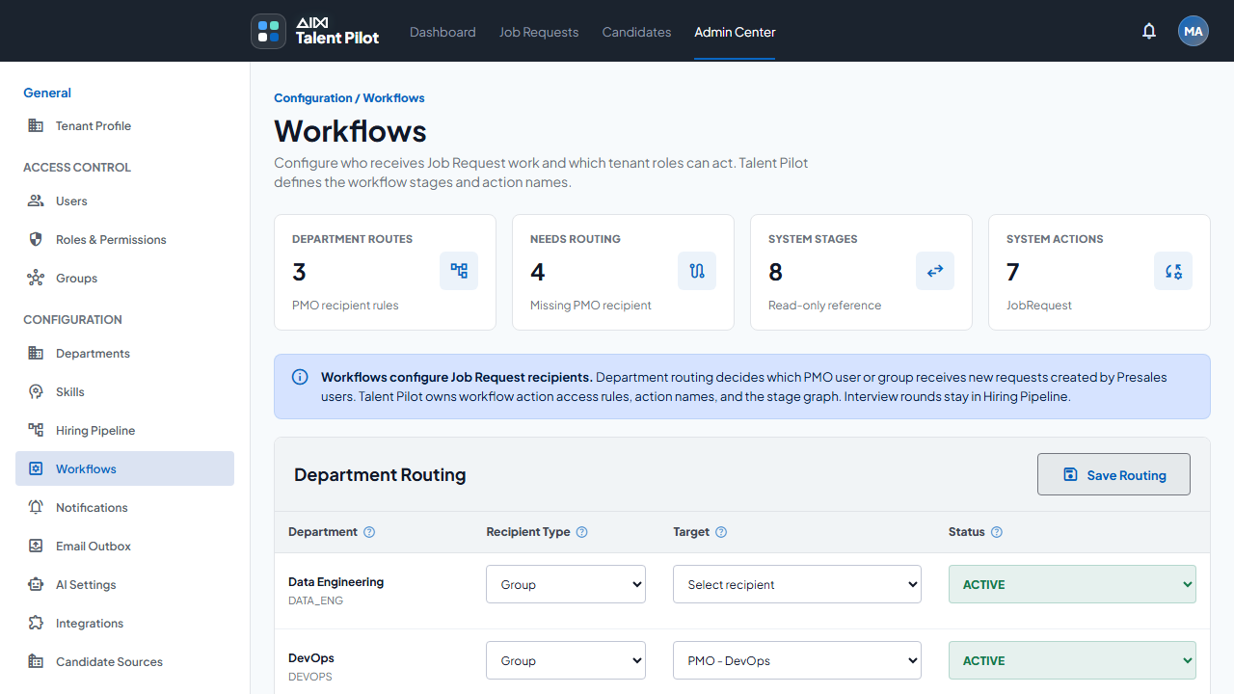
Live screenshot: Admin Center Workflows showing department routing and system workflow controls.

External Integrations And Service Accounts
Section summary
- The app integrates with AI runtime, database, email, calendar, realtime notifications, public search providers, and GitHub API.
- Only provider purpose and configuration key names are documented.
- Actual secrets, passwords, connection strings, API keys, OAuth client secrets, and tokens are excluded.
- Most providers are configurable by environment and should use deployment secret storage.
- Bench Matching public search is intentionally limited and must not include employee personal data.
- Online Headhunting uses approved source search and GitHub public profile search, but remains lead-only.
- Calendar and email integrations support interview scheduling and communication workflows.
- Google Calendar conflict detection and automatic slot suggestions are roadmap work, not current behavior.

Provider | Purpose | Config keys or setting names | Secret shown here?
Ollama | Local LLM and embedding runtime | OllamaBaseUrl, LlmModel, EmbeddingModel, EmbeddingDimensions | No. Runtime endpoint and model names only.
SQL Server | Application data and vector store | ConnectionStrings.TalentPilot, VectorStore | No. Connection string values are secret.
Resend | Transactional email provider | Notification provider, Resend API key, From email | No. API key is secret.
Microsoft Graph | Alternative email/calendar provider | Tenant/client identifiers, scopes, credentials | No. Credentials and tokens are secret.
Google Calendar | Interview calendar and meeting scheduling | OAuth client configuration, callback, token store | No. OAuth secret and tokens are secret.
Tavily Search | Controlled public web research and Online Headhunting source-link discovery | TavilySearch.BaseUrl, DailyRequestLimit, API key | No. API key is secret.
Google Custom Search | Alternative public search provider for controlled search/source-link discovery | Search engine id, API key | No. API key is secret.
GitHub API | Public developer profile search for Online Headhunting | GitHubSearch.Enabled, GitHubSearch.ApiBaseUrl, GitHubSearch.Token, GitHubSearch.RequestTimeoutSeconds | No. Token is secret.
SignalR | Realtime in-app notifications | Hub URL and JWT access_token flow | No service account.

Configuration Principle
The documentation intentionally lists key names and business purpose, not secret values. Production deployments should use environment variables, user-secrets, vault-backed configuration, or platform secret stores. The database connection string, JWT signing key, email API keys, OAuth client secrets, search API keys, and service tokens should never be committed to documentation.
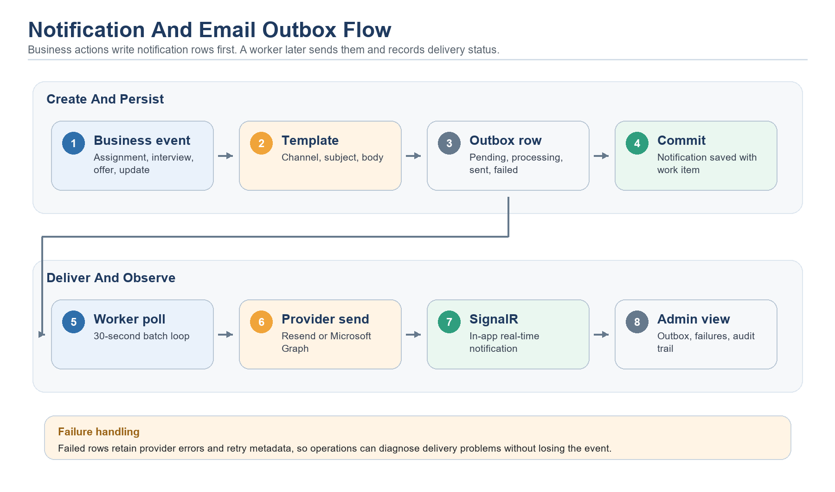
Diagram: notification outbox and email provider flow.

Google Calendar And Interview Scheduling
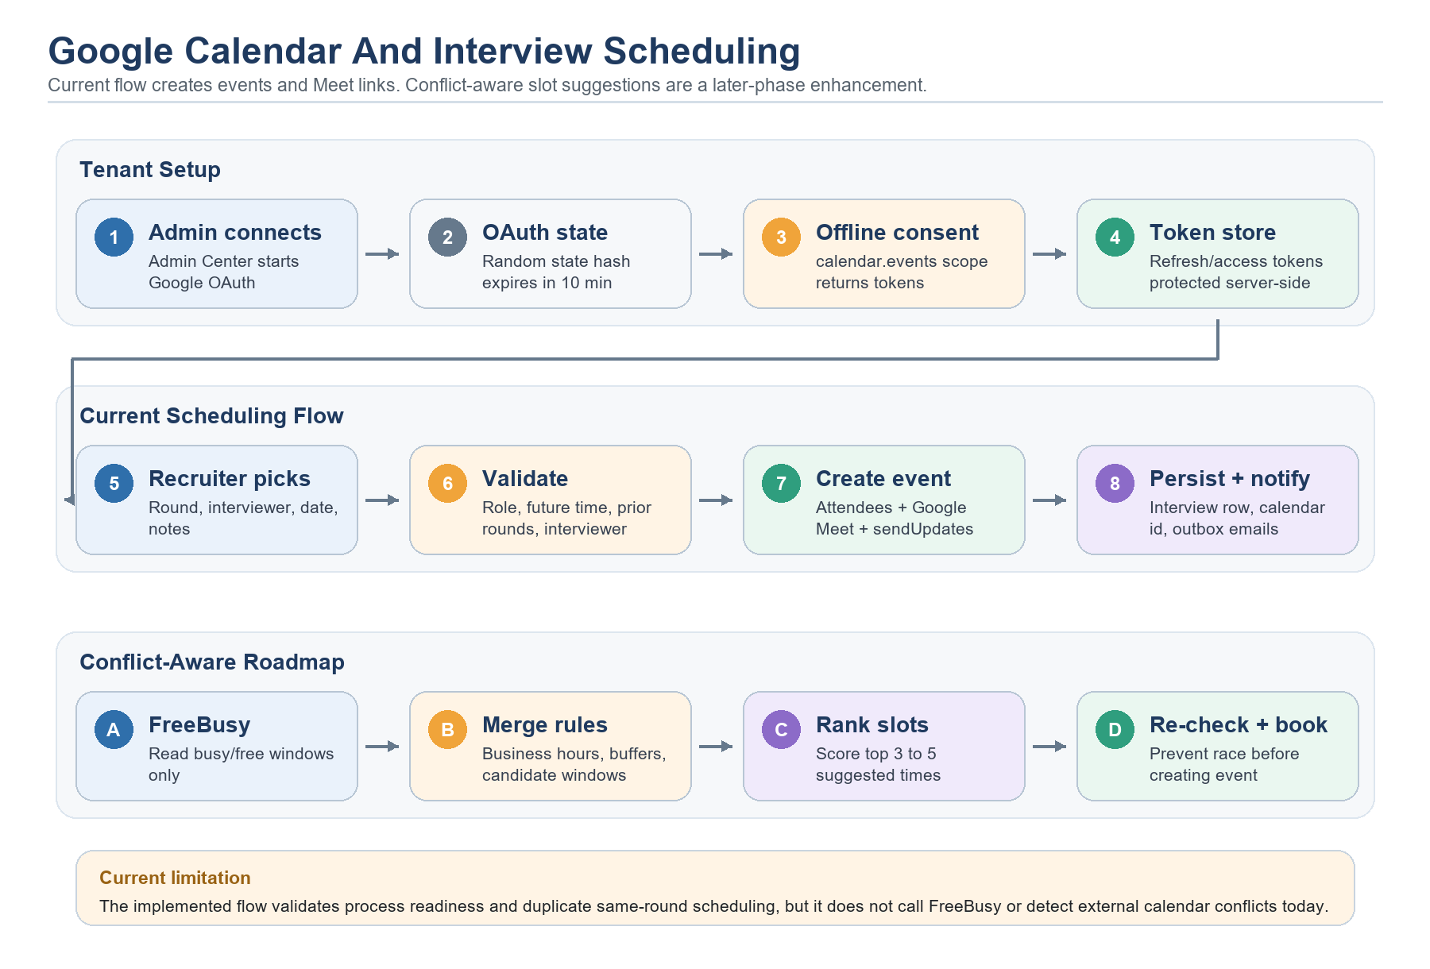
Diagram: Google Calendar setup, current interview scheduling, and conflict-aware roadmap.
Google Calendar is used to create interview events and meeting links. A Tenant Admin connects the organizer calendar account from Admin Center > Integrations. Recruiters then schedule interviews from recruiter sourcing after the interview round is ready. The frontend does not ask recruiters to paste a manual meeting link in the normal flow; it sends the round, interviewer, date/time, and notes to the API, and the backend creates the calendar event.
The backend uses OAuth, not a Google password. It creates a random state token, stores only its hash with a 10-minute expiry, redirects the admin to Google consent, exchanges the authorization code for tokens, and stores protected refresh/access tokens server-side. The default scope is https://www.googleapis.com/auth/calendar.events. Current Admin Center status shows whether calendar access is connected, but it should not be treated as verified proof of the exact Google account identity.
Area | Current behavior | Technical detail
Google Calendar setup | Tenant Admin connects an organizer account from Admin Center > Integrations. | Backend builds an OAuth URL, stores a hashed state token with a 10-minute expiry, requests offline access, and stores protected refresh/access tokens.
Scheduling permission | Recruiter or Tenant Admin schedules the next interview round from recruiter sourcing. | OperationsService checks role codes before doing any scheduling work.
Round readiness | The selected round must exist, prior rounds must be completed or skipped, and the round must have an active interviewer. | Repository validation returns Ready, PriorRoundsPending, RoundAlreadyScheduled, MissingInterviewer, or NotFound.
Calendar request | Talent Pilot builds a title, description, start/end time, time zone, and attendees. | InterviewCalendarMeetingFactory includes candidate, hiring manager, interviewer, recruiter context, round name, job title, and notes.
Google event creation | GoogleCalendarMeetingService refreshes the access token and inserts a calendar event. | The request uses the configured calendar id, sendUpdates=all, attendee emails, and Google Meet conference data when no existing meeting link is supplied.
Persistence and notification | The app saves the interview, Google event id, event link, meeting link, status, and participants. | The repository updates application status to Interviewing when needed, writes audit/status history, and queues candidate/interviewer/hiring-manager emails.

What The Calendar Event Contains
- Title format comes from InterviewCalendarMeetingFactory, for example: round name, candidate name, and job title.
- Description includes company, request code, candidate, round, recruiter, and optional location or notes.
- Attendees include candidate, hiring manager, and interviewer, deduplicated by email address.
- Start and end time use the interview round duration and tenant/request time zone, falling back to UTC.
- Google Meet conference data is requested when no existing meeting link is supplied.
- Google Calendar is called with sendUpdates=all so Google sends participant calendar invitations.
- Talent Pilot also queues its own candidate, interviewer, and hiring-manager notification emails through the notification outbox.

Current Conflict Checking Boundary
Current implementation does not call Google FreeBusy and does not inspect every participant calendar for conflicts. It validates workflow readiness, future start time, active interviewer, prior round completion, and duplicate scheduling of the same round.

So today, if an interviewer already has another meeting on Google Calendar, Talent Pilot will not automatically detect that conflict before creating the event. Google may still show the conflict to the participant inside Google Calendar, but the application does not use that signal to block or suggest another slot.

Can We Suggest A Time That Suits Everyone?
Yes. This is a strong later-phase improvement. The safest design is to add an availability service that checks internal participant busy/free windows, merges those windows with candidate-provided availability and existing Talent Pilot interviews, generates possible slots, scores them, and then re-checks the chosen slot immediately before booking.
Roadmap area | Recommended improvement | Why it matters
Availability access | Add Google FreeBusy or read-only calendar scopes for internal participants, or use Google Workspace domain-wide delegation where the customer owns the domain. | Today the app mainly has a connected organizer account and calendar.events scope; it cannot assume access to every participant calendar.
Candidate availability | Use candidate-provided availability windows or a self-scheduling link instead of requiring direct access to the candidate's personal calendar. | External candidates usually will not grant calendar read access to the hiring system.
Slot generation | Generate possible slots from duration, business hours, time zones, buffers, lead time, working days, and interview-round rules. | This can be deterministic and does not need an LLM.
Conflict merge | Merge Google busy blocks, existing Talent Pilot interviews, interviewer load, and candidate windows. | Only busy/free windows should be stored or cached; event titles and private calendar details should not be retained.
Slot scoring | Rank slots by earliest acceptable time, all required participants free, candidate-friendly hours, recruiter SLA, and interviewer load balance. | Return 3 to 5 suggested slots to the recruiter or candidate.
Final booking | Re-check availability immediately before creating the Google event. | This avoids race conditions when someone becomes busy after suggestions are shown.

Roadmap code sketch: conflict-aware slot suggestions
// Simplified future conflict-aware scheduling flow
context = await repository.GetInterviewScheduleContextAsync(...);
meetingRequest = InterviewCalendarMeetingFactory.Build(
context,
proposedStartUtc,
locationText,
requestId);
participants = meetingRequest.Participants;
googleBusy = await availability.FreeBusyAsync(participants, searchWindow);
localBusy = await repository.ListScheduledInterviewBusyBlocksAsync(
tenantId,
participants,
searchWindow);
candidateWindows = context.CandidateAvailabilityWindows;
slots = SlotFinder.Generate(
duration: context.DurationMinutes,
businessHours: tenant.BusinessHours,
buffers: tenant.InterviewBuffers,
googleBusy,
localBusy,
candidateWindows);
suggestions = slots
.OrderByDescending(slot => SlotScorer.Score(slot, context))
.Take(5);
// Re-check the selected slot just before event creation.
if (await availability.HasConflictAsync(selectedSlot, participants))
return Result.Failure("calendar.conflict_detected", "Selected time is no longer available.");

Later-Phase Improvements
- Add a calendar availability abstraction such as ICalendarAvailabilityService so Google Calendar and Microsoft Graph can share the same scheduling algorithm.
- Add Google FreeBusy integration for internal participants, with minimal scopes and tenant-level consent controls.
- Add candidate self-scheduling links where candidates choose from recruiter-approved slots instead of exposing private calendars.
- Store only free/busy windows or chosen meeting metadata, not private calendar event titles or descriptions.
- Add interviewer workload balancing so the same interviewer is not overbooked across many open roles.
- Add local overlap checks against Talent Pilot interviews even before external calendar data is available.
- Add audit logs for availability checks, slot suggestions, final booking, Google rejection, and rescheduling.

Testing Coverage
The repository includes tests for the Google Calendar service, meeting factory, and scheduling emails. Current tests cover connect URL behavior, clear errors when Google Calendar is not connected or storage is missing, token refresh and Meet event creation, participant and description construction, and generated email content. Future conflict-aware scheduling should add deterministic tests for slot generation, time zones, buffers, race re-checks, no-availability results, and privacy-safe FreeBusy handling.

Audit Logs, Analytics, And Prediction Opportunities
Section summary
- The app stores audit logs, AI run logs, recommendation logs, workflow history, notification outbox state, and application status history.
- These records can support operational analytics and compliance review.
- Useful analytics include time-to-fill, workflow bottlenecks, AI recommendation acceptance, source quality, and notification reliability.
- Prediction is possible, but should be privacy-safe, tenant-scoped, and validated before operational use.
- AI outputs should be measured against hiring outcomes and user feedback.
- Audit logs should help explain who changed what, when, and why.

Data source | What it stores | Analytics use
AuditLogs | Actor, tenant, event, entity, timestamp, metadata | Security review, change history, admin behavior trends.
AiAgentRuns | Agent, model, request, result, latency, status | Model reliability, cost/runtime patterns, prompt quality.
AiRecommendationLogs | Recommendation evidence, score, explanation, related entity | Acceptance rate, score calibration, bias or drift review.
WorkflowHistory | Stage, transition, assignee, actor, time | Bottlenecks, SLA tracking, routing quality.
NotificationOutbox | Provider, status, retry count, error text | Delivery health, failure patterns, channel reliability.
JobApplicationStatusHistory | Candidate progress through stages | Conversion funnels, time in stage, source quality.
Candidate profile/application data | Skills, experience, education, source label, job interest | Market demand signals, skill-gap reporting, talent pool planning.

Can Audit Logs Be Used For Analytics?
Yes. Audit logs can support dashboards that show configuration changes, sensitive actions, workflow decisions, and operational activity over time. They can also help identify unusual behavior, repeated failed actions, heavy administrative changes, or areas where users are blocked by permissions or process friction.

Can The Data Predict User Or Application Behavior?
Potentially, but prediction should be treated as a roadmap capability. The system has enough structured history to estimate bottlenecks, likely time-to-fill, source quality, candidate drop-off risk, and workload pressure. Before using predictions in production, the team should validate accuracy, monitor bias, define privacy rules, and clearly show users that predictions are recommendations rather than facts.
- Predict job requests likely to miss fulfillment timelines.
- Identify departments with repeated routing delays.
- Estimate candidate drop-off risk from status history and communication gaps.
- Recommend best candidate sources by role, skill, and location.
- Detect AI recommendation drift when model changes alter score distributions.
- Forecast demand for specific skills based on open roles and historical requests.

Candidate Portal And Market Data Potential
Section summary
- Candidates can browse public jobs and must log in before applying.
- The portal captures profile, CV, skills, education, work history, application source, and status history.
- Candidate data supports applicant ranking, interview flow, status tracking, and reporting.
- Source labels and application history can show which channels produce qualified candidates.
- Aggregated, privacy-safe data can help understand skill demand and job-market trends.
- Candidate analytics should avoid exposing personal data beyond legitimate hiring operations.


Diagram: candidate portal and hiring pipeline.

How Candidate Portal Works
- A candidate opens the public job list or a direct job link.
- The candidate can review job details before applying.
- Applying requires candidate authentication.
- The candidate profile captures contact details, skills, education, work history, CV evidence, and related application data.
- The application stores source information so recruiters can understand where the candidate came from.
- The application tracks status history across submission, review, interviews, offer, reject, hold, withdraw, joined, or reapply-blocked states.
- Recruiters and hiring managers use profile data, CV parser output, ranking evidence, interview feedback, and workflow state to make decisions.

Data Logged For Hiring Operations
- Candidate identity and contact data needed for hiring communication.
- Skills, experience, education, work history, profile URL, and CV document metadata.
- Application source label, source details, recruiter notes, and manual source fields.
- Application status history and timestamps.
- Interview schedule, feedback, and outcome data.
- AI parse, ranking, and recommendation logs where agents are used.

Market Trend Potential
Candidate portal and job application data can reveal market trends when aggregated safely. For example, the organization can compare skill demand from job requests with skill supply from applicants, see which locations respond faster, identify salary or notice-period friction if those fields are captured, and measure which sources produce interview-ready candidates. This should be tenant-scoped and privacy-safe, with personal identity removed from trend reporting.
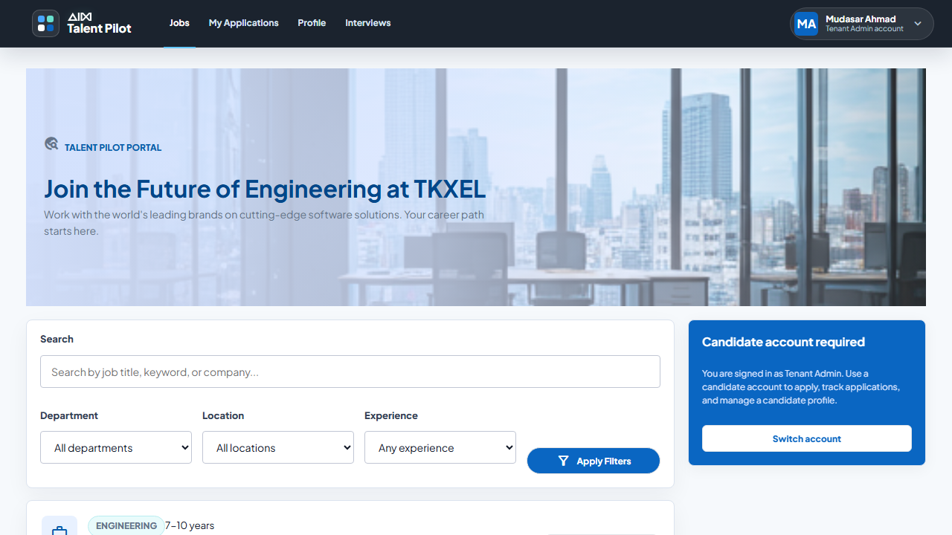
Live screenshot: current candidate jobs portal view. It shows the portal while an admin session is active, including the candidate-account requirement.

Roadmap And Improvement Plan
Section summary
- Roadmap items are recommendations, not implemented behavior unless explicitly stated elsewhere.
- The biggest security improvement is stronger browser session handling and enterprise SSO.
- The biggest AI improvement is outcome-based evaluation and prompt/model versioning.
- The biggest analytics improvement is converting logs into tenant dashboards and calibrated predictions.
- The biggest workflow improvement is a safer configurable rules engine for more runtime control.

Recommended Next Improvements
Area | Recommended improvement | Why
Authentication | HttpOnly Secure refresh cookie or BFF pattern; OIDC/SSO; richer session audit. | Reduces browser token risk and fits enterprise deployment.
AI governance | Prompt versioning, output schemas, model comparison reports, feedback capture. | Makes AI behavior measurable and tunable.
Vector lifecycle | Admin reindex jobs, model compatibility checks, embedding backfill status. | Makes embedding model changes safer.
Workflow | Versioned workflow/rules engine with validation and simulation. | Expands configurability without allowing invalid state movement.
Analytics | Dashboards for time-to-fill, source quality, AI usefulness, bottlenecks. | Turns operational history into leadership insight.
Candidate privacy | Consent-aware analytics, retention rules, anonymized trend reports. | Supports market insights while protecting candidates.

Source Notes And QA Checklist
Section summary
- The document was generated from current repository docs, backend/frontend code, SQL scripts, and live screenshots.
- No Stitch/reference screenshots are included.
- Secret values are not included.
- Section summaries are kept under the 20-line limit.
- Screenshots are from the current running app and are labeled as such.
- Roadmap items are marked as recommendations rather than implemented behavior.

Evidence type | Source
Canonical docs | TALENT_PILOT_SOURCE_OF_TRUTH.md, ARCHITECTURE.md, README.md
Backend | Application Code/Backend Code/src/TalentPilot.*
Frontend | Application Code/Frontend Code/src/app and public assets
Database | Application Code/Backend Code/database/scripts/*.sql
Knowledge base | knowledge-base and current implementation notes in the repository
Screenshots | Generated Documentation/screenshots captured from the running app on June 4, 2026

QA Checklist
- No actual passwords, API keys, tokens, connection-string values, service-account JSON, or private secret values are present.
- No Stitch/reference screenshots are embedded.
- Each major section begins with a summary of fewer than 20 lines.
- Diagrams are generated specifically for this documentation from current implementation understanding.
- Live screenshots are captured from the current running application.
- Rendering QA should be performed after DOCX generation and layout issues should be fixed before delivery.

